GLY 110
HW Problem # 1
Relative and Absolute Age Dating

- A crystal of the mineral “Zircon” separated from an igneous rock was analyzed for the two isotopes ²³⁸U and ²⁰⁶Pb. It was found to contain 1009 atoms of ²³⁸U and 191atoms of ²⁰⁶Pb. Knowing that the half life of ²³⁸U is 4.5 billion years, how old is this zircon crystal? Use the graph provided to help you with this calculation. (Hint: You need to determine the values of N, D and N° to use this curve, or use the relation: λ = 0.693 T_{1/2} and the equation of radioactive decay). Show your calculations.

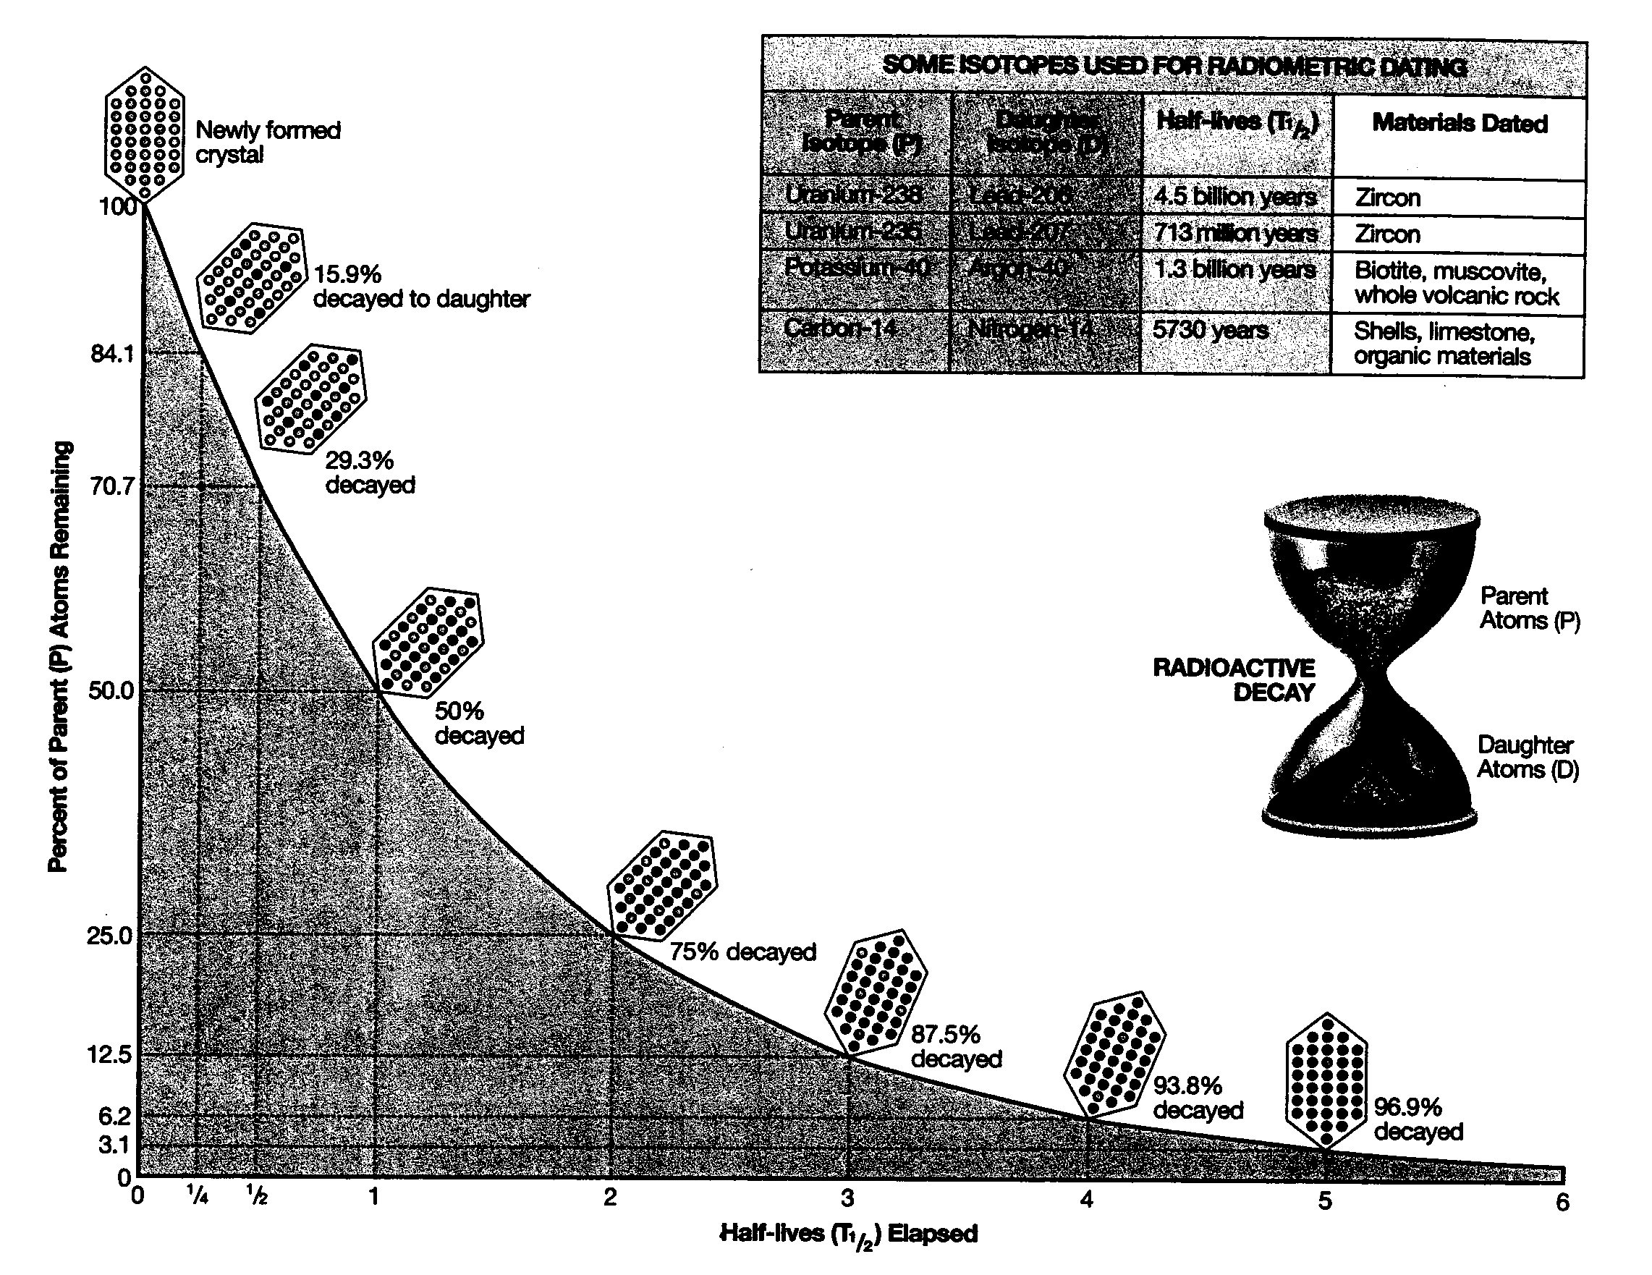
N/N°
%

- (a) On the cross section shown below, arrange the units and surfaces in reverse chronological order (from oldest to youngest).
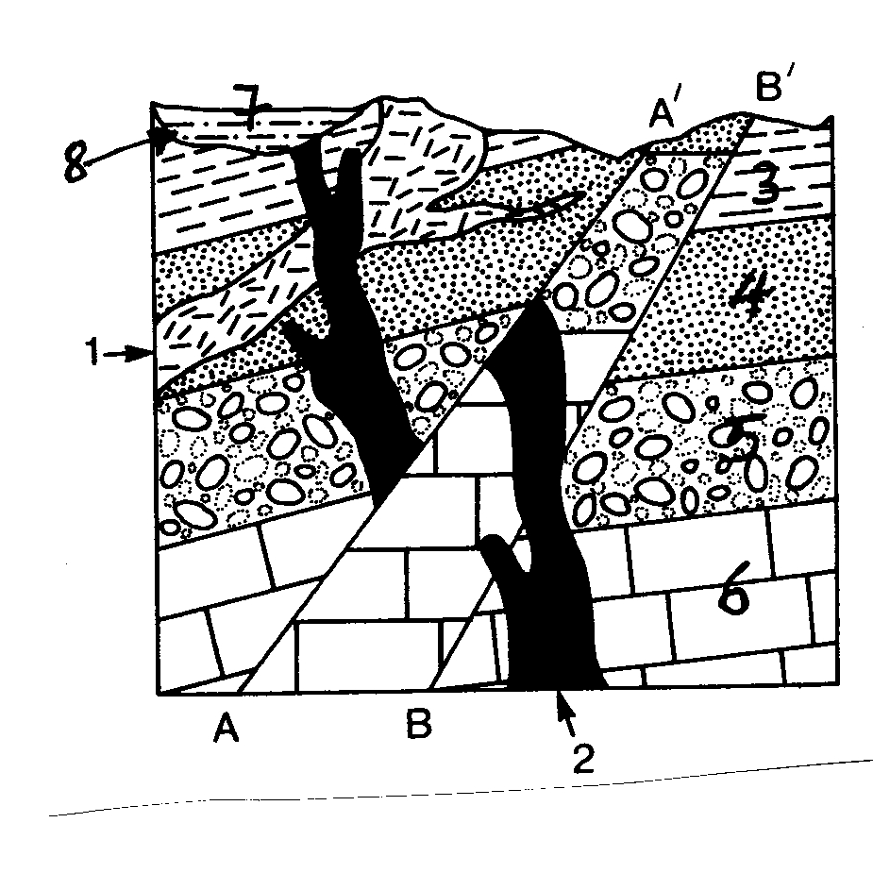

Youngest: ____________________
____________________________
____________________________
____________________________
____________________________
____________________________
____________________________
____________________________
____________________________
Oldest: ______________________

(b) What kind of rock forms the feature labeled “1”?

(c) What kind of rock forms the feature labeled “2”?

