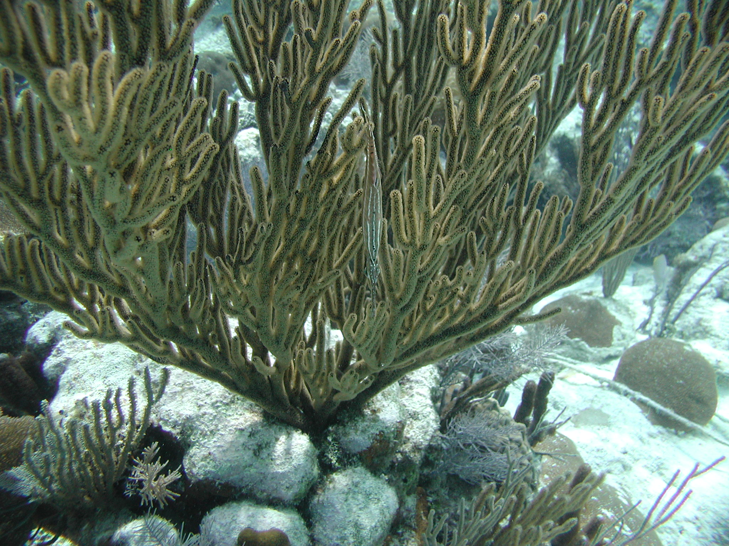

Black Sea Rod
Plexura sp.

Size
Can get up to 6 feet

Depth
Fun Facts:
- Sea rods have
stiff but flexible internal skeletons.

Found in patch reef in clear water.

Visual Aid
Stalks are black which contrasts with the yellow brown polyps.
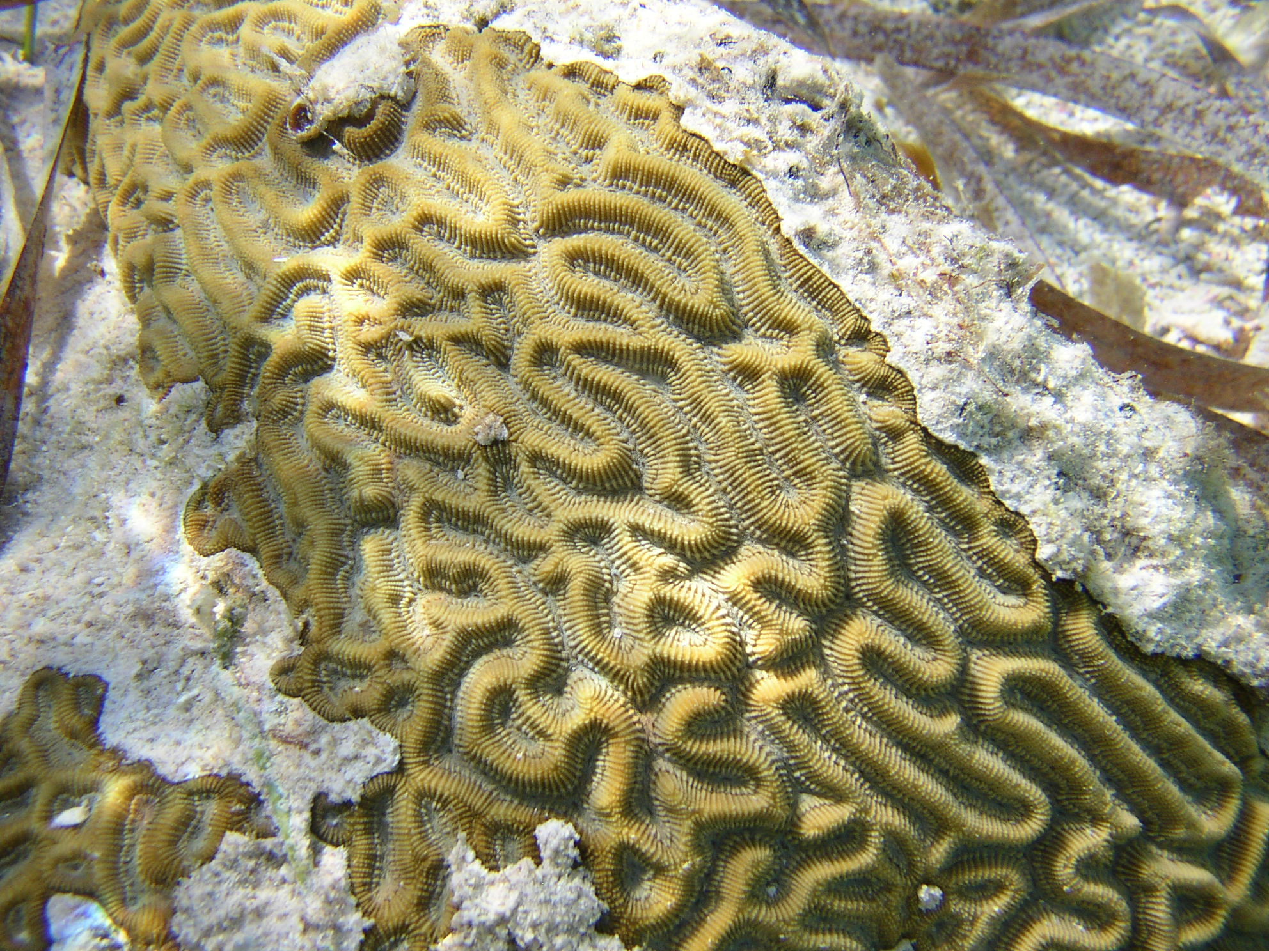

Common Brain Coral
Fun Facts:
- This coral looks like the grooves in your brain, hence the name Brain Coral.
Diploria strigosa

Size:
1-6 feet
Depth:
20-40 feet

Visual Aid: Common coral resembles a brain
with its deeply grooved, hemispherical head.
Color is dull ranging from green to brown.

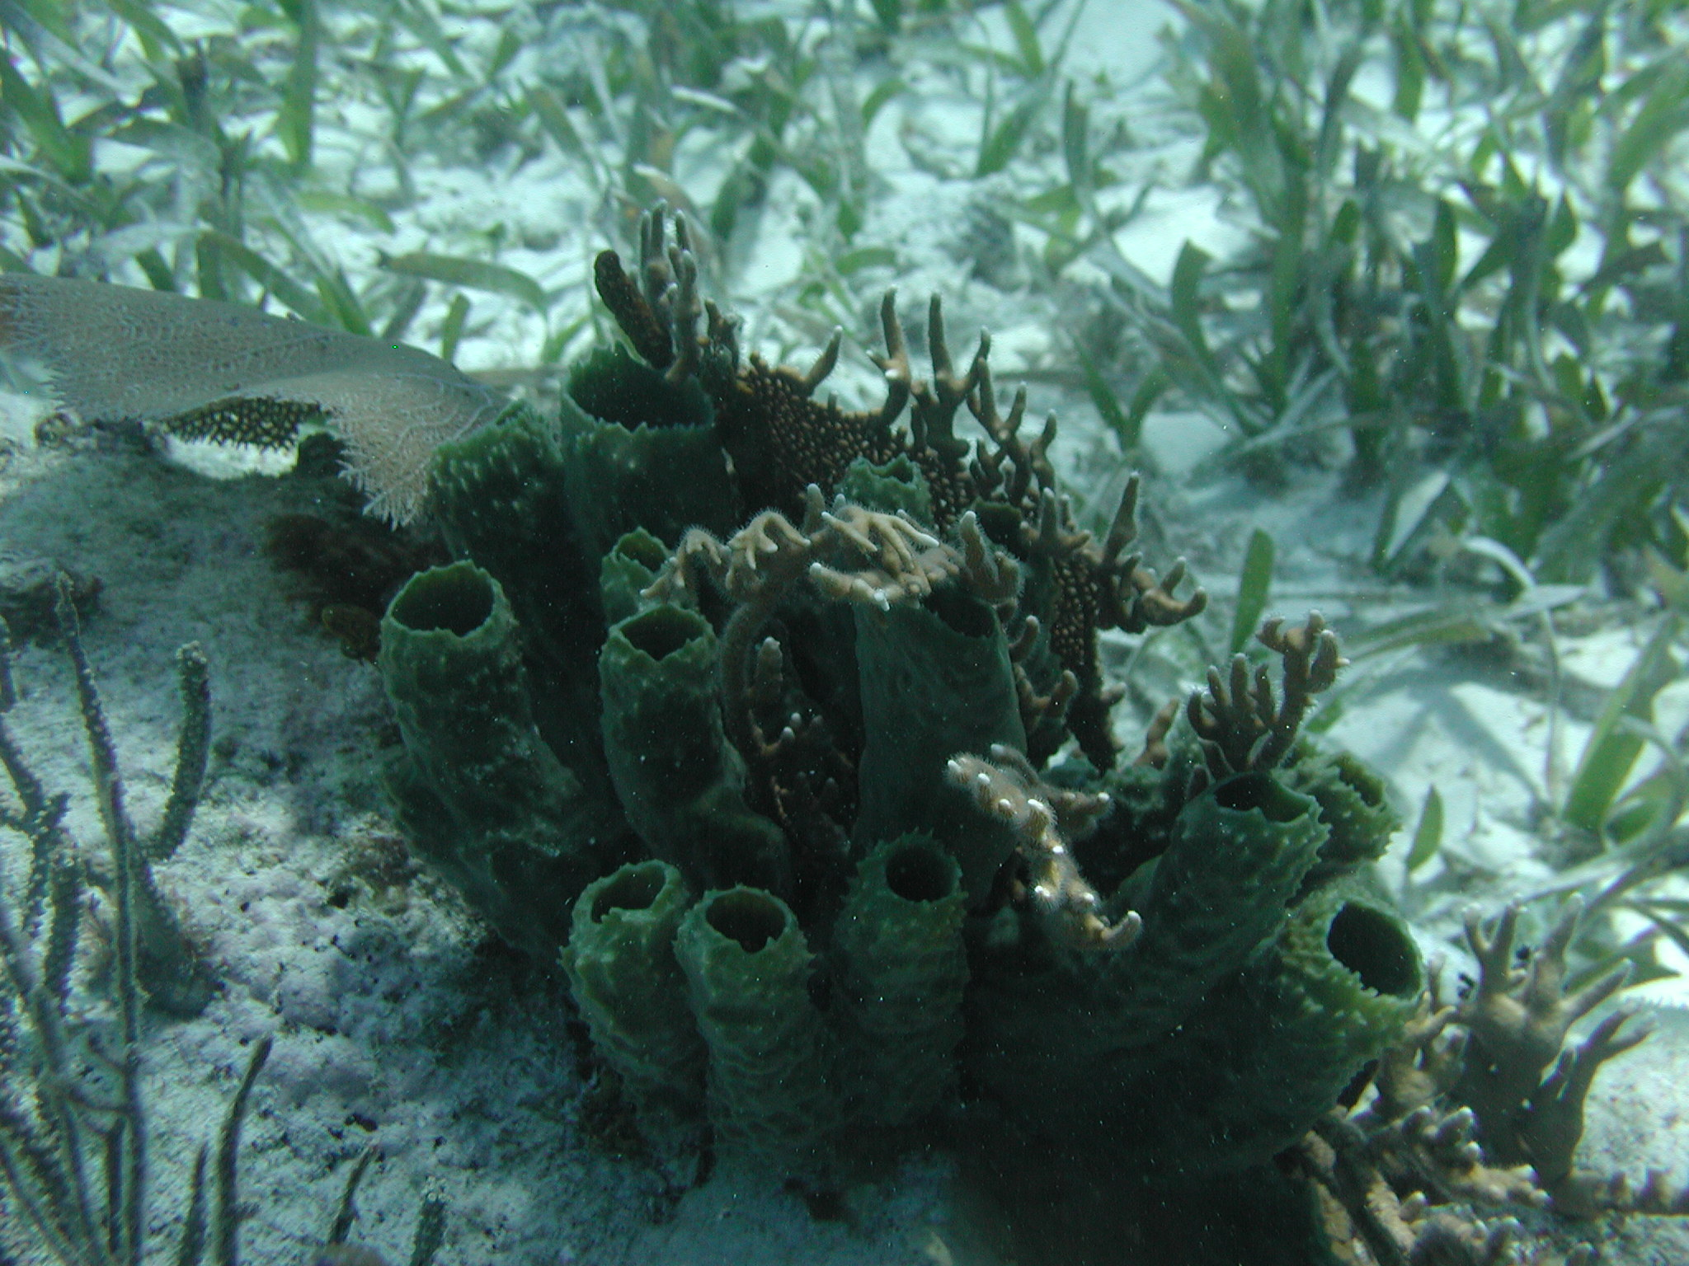

Branching Vase Sponge
Fun Facts:
- Sponges are one
of the most primitive animals in the sea
- The branching
vase sponge is one of the most common varieties of sponge.

Callyspongia vaginalis

Size
6-36 inches
Depth
6-65 feet

Visual Aid
Thin, stiffed-walled tubes. Outer walls have
irregular conical projections. Found in
clusters, ranging from 20-30 tubes. Color varies
from lavender to brownish-gray to greenish-gray.
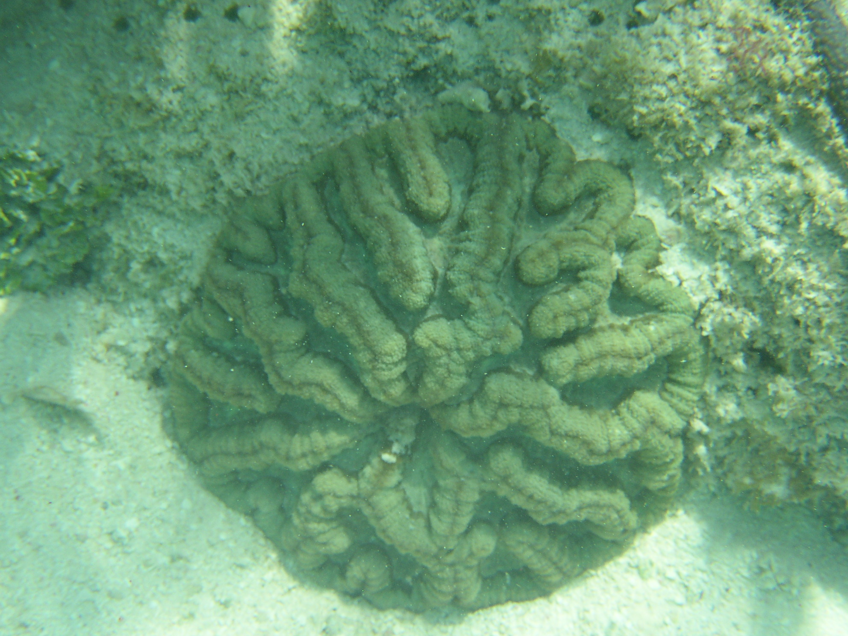

Cactus Coral
Pavona sp.
Fun Facts:
- Corals in general help purify the water.
- Coral is among the oldest living organisms in the world.

Size
6-18 inches

Depth
Random current, strong light.
Found in shallow waters

Visual Aid
Form plates with meandering ridges.

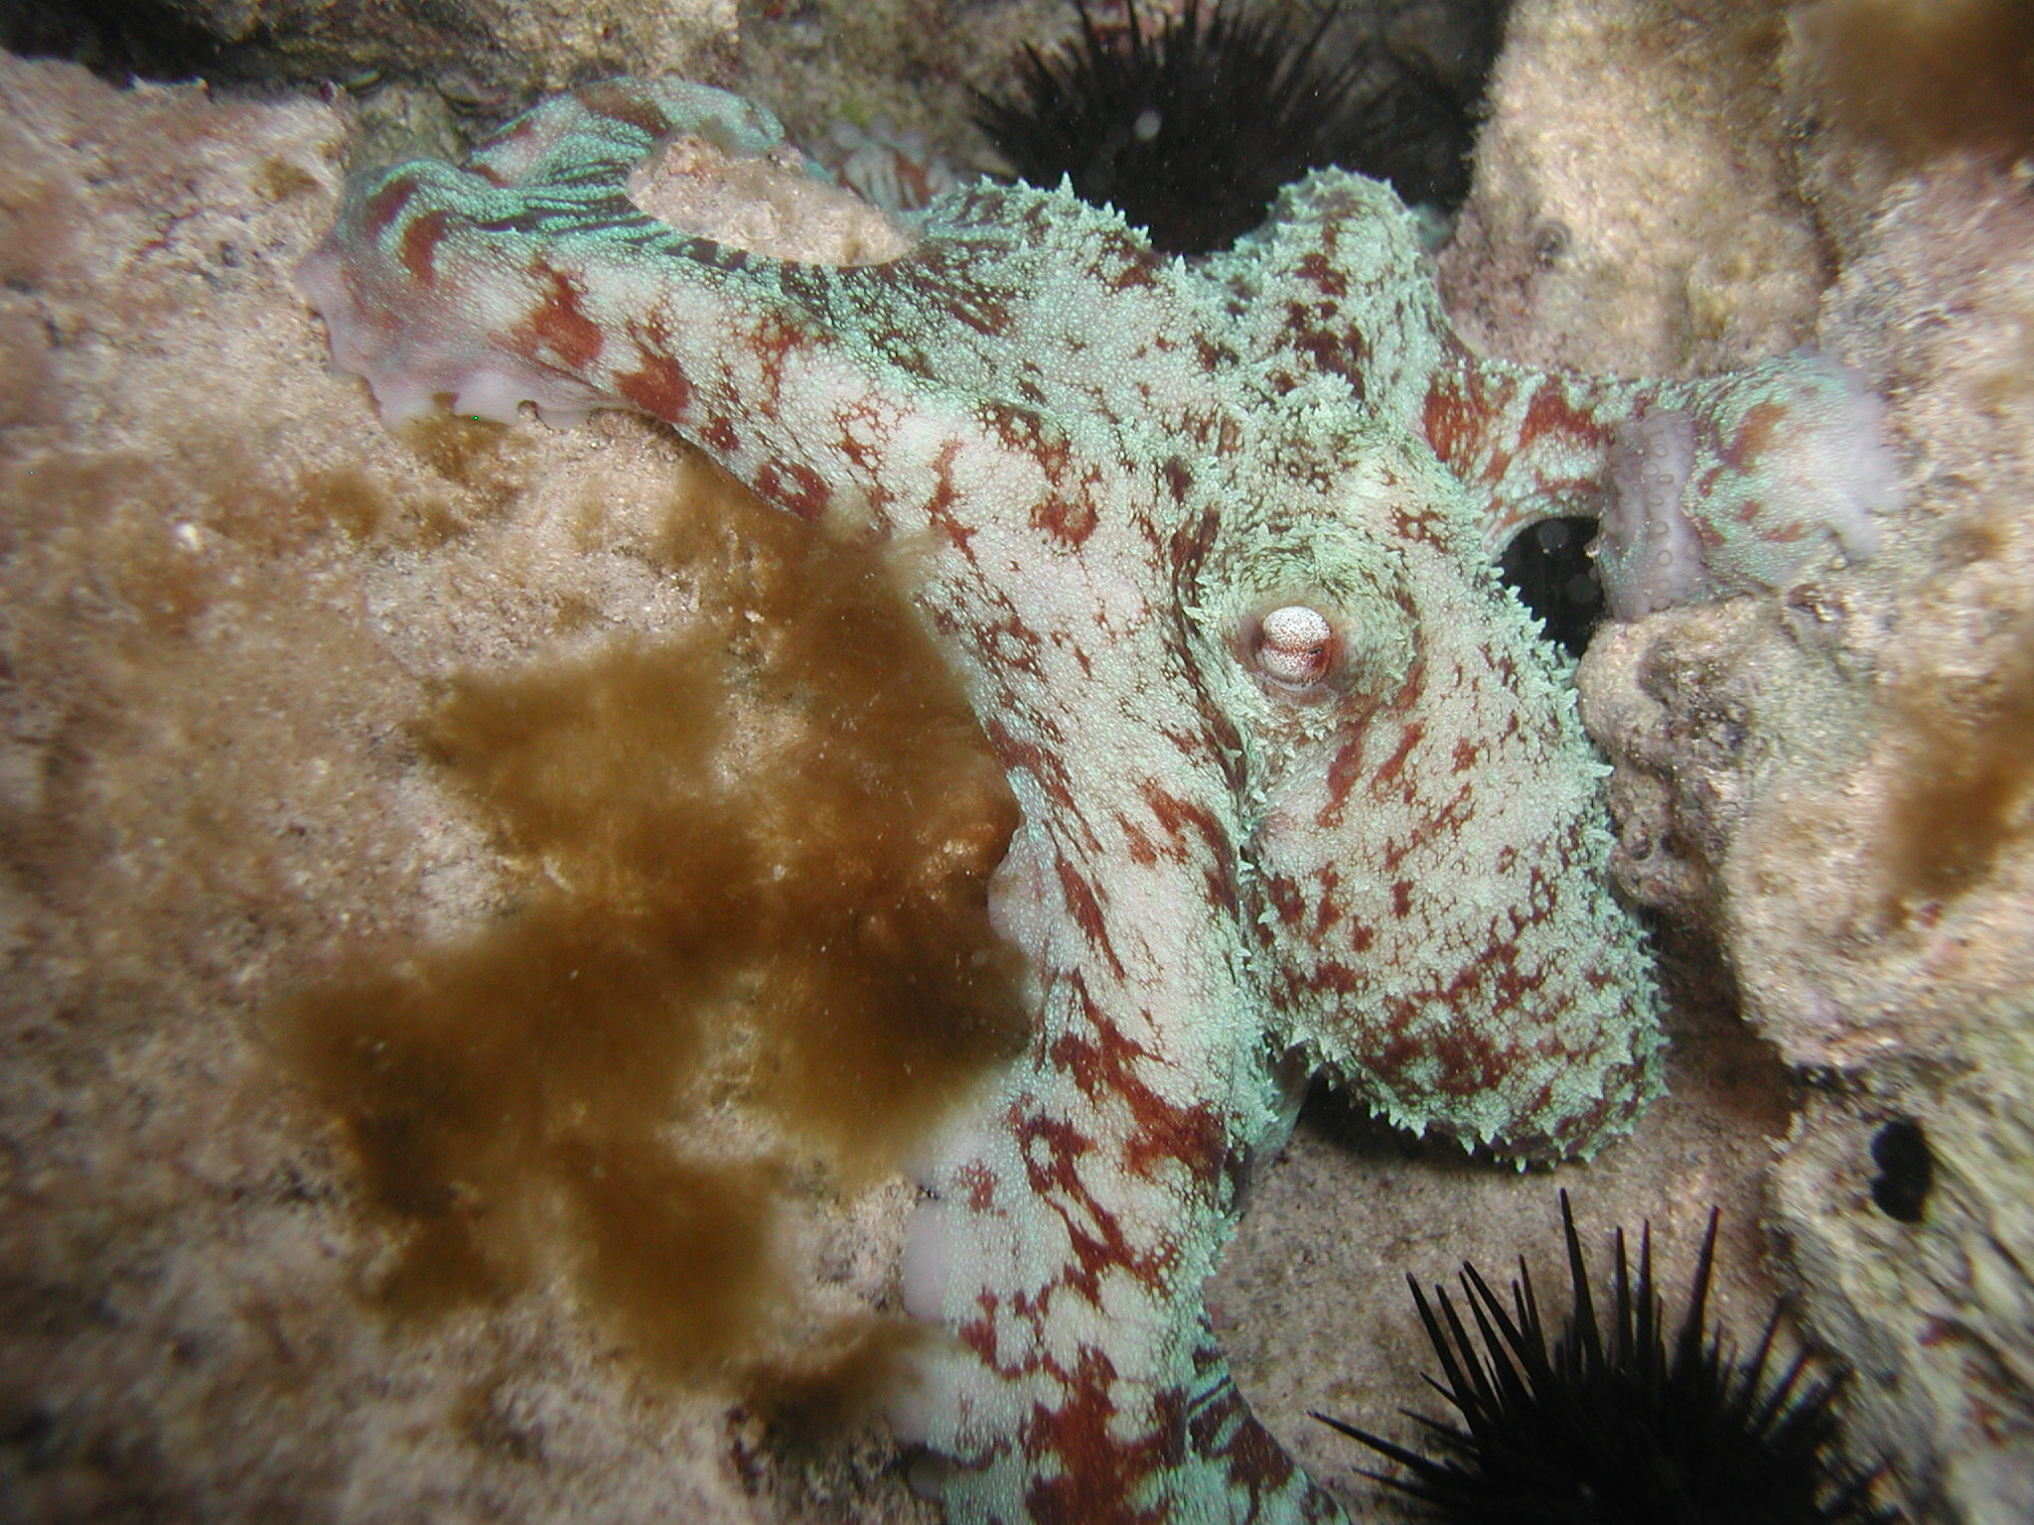

Caribbean Reef Octopus
Fun Facts:
- The octopus swims by spewing water from its body, a type of jet propulsion.
- Octopuses are nocturnal, active at night.
- Octopuses have the ability to change their skin color to blend in with their surroundings.
Octopus briareus

Size:
12-20 inches
Depth:
15-75 feet

Visual Aid:
Pale to intense iridescent blue-green cast,
often with brown mottling. Dark ring around eye,
no dark edge around suckers. Skin relatively
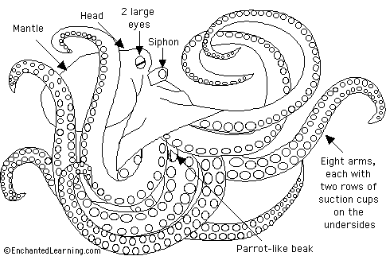
smooth with small scattered
wart-like papillae.
Arms 4-6 times body length.
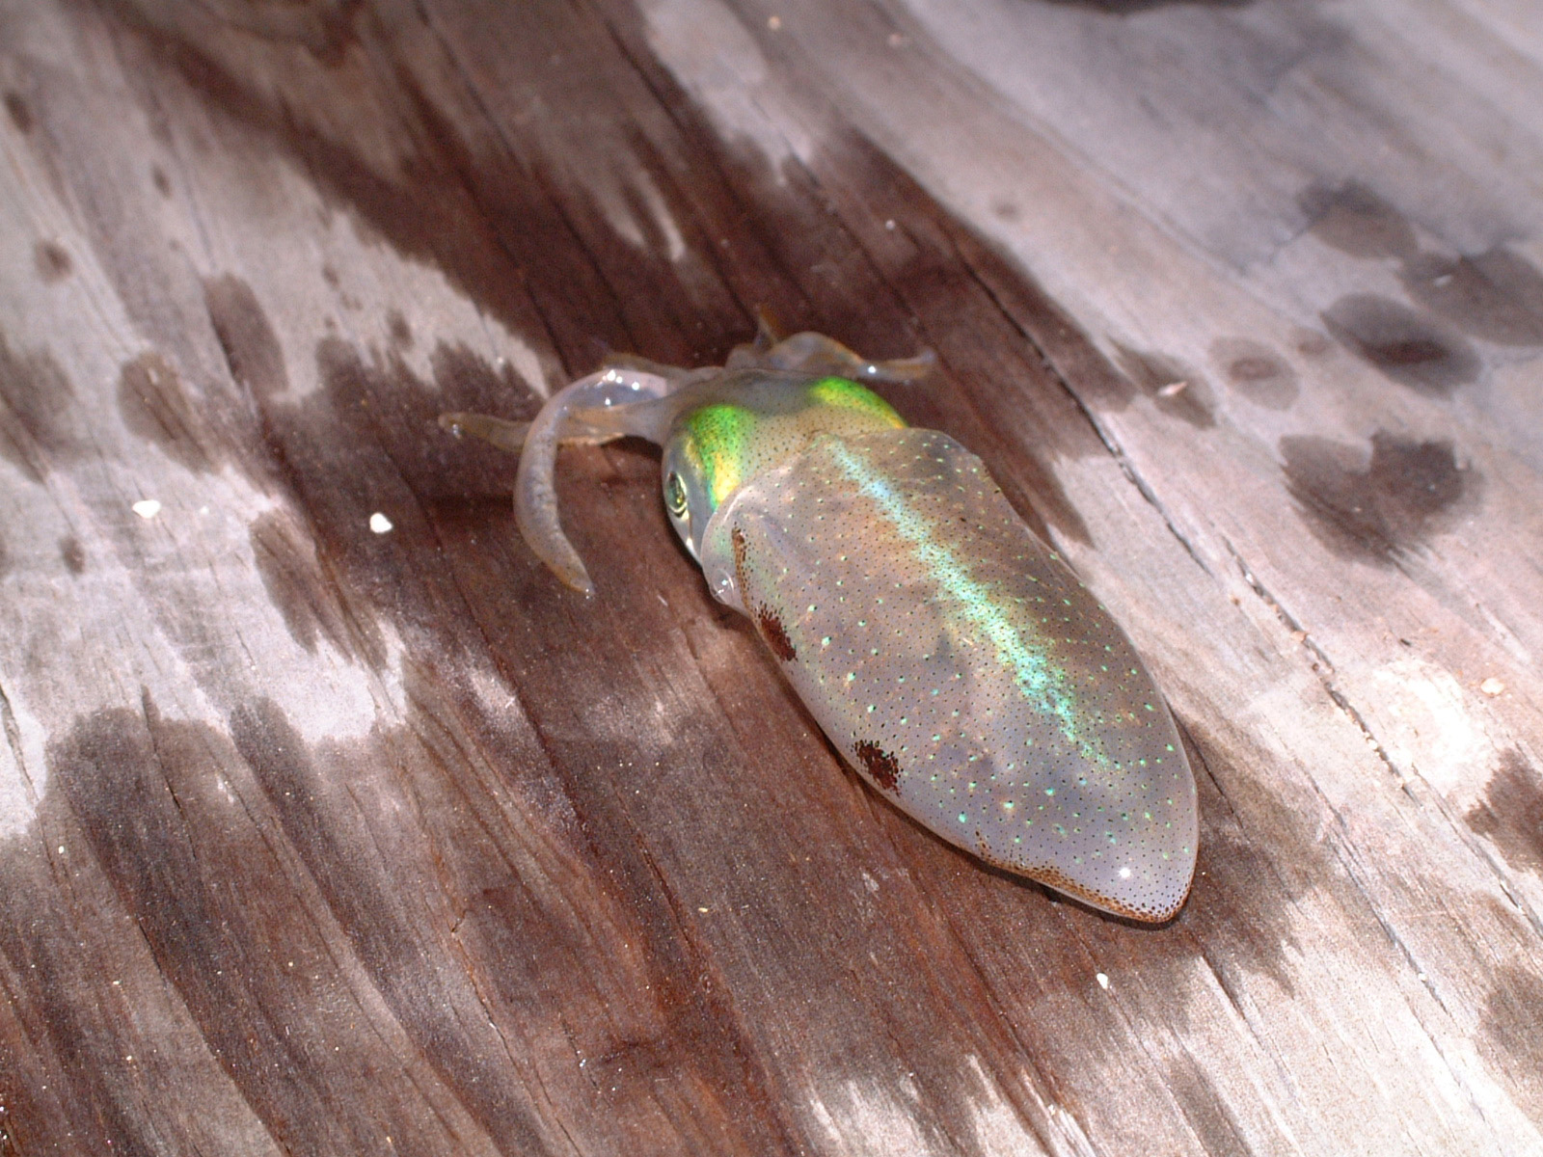

Caribbean Reef Squid
Sepioteuthis sepioidea
Fun Facts:
- Only squid
Commonly found in Caribbean reefs.
- All are
carnivores.

- Live together in
groups of ten to thirty individuals called a shoal.
Size:
6-12 inches
Depth:
1 foot-60 feet

Visual Aid: Entire length oblong
body bordered by thin fin. Color varies:
during day shades of gray with
white spots; at night mottled and
spotted in shades of white,
brown, green, and lavender,
may be iridescent. Arms shorter than body.
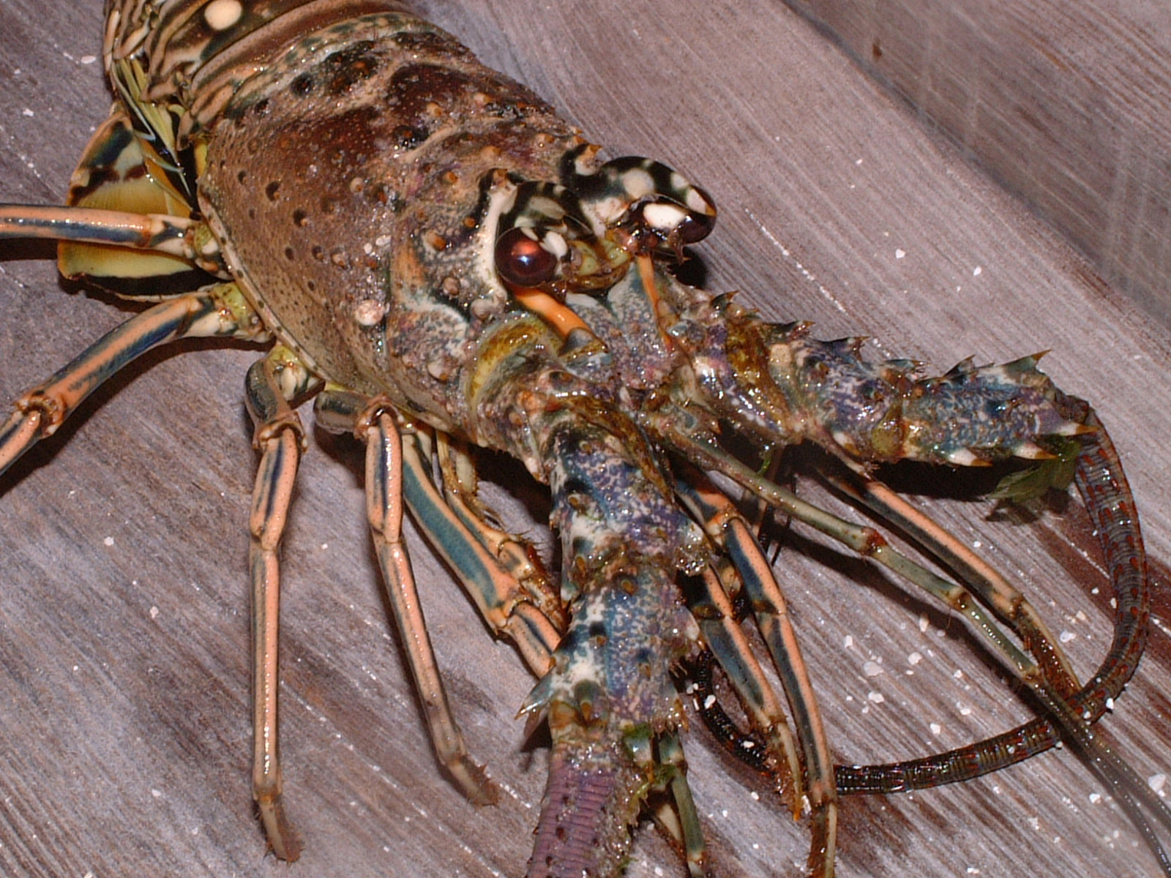
Caribbean Spiny Lobster
Fun Facts:
- Predators include
nurse sharks, octopus, groupers, large rays, trigger fish and humans.
- Populations have
declined because of tourism and industry.
- The most abundant
lobster species in the Caribbean.

Panulirus argus
Size:
6-10 inches 2 feet max.
Depth:
3-130 feet
Visual Aid: Carapace has shaded area of brown
and tan with few dark spots, abdomen is brown
and tan banded with few light spots. They
have sharp “horns” above eyes and a pair of
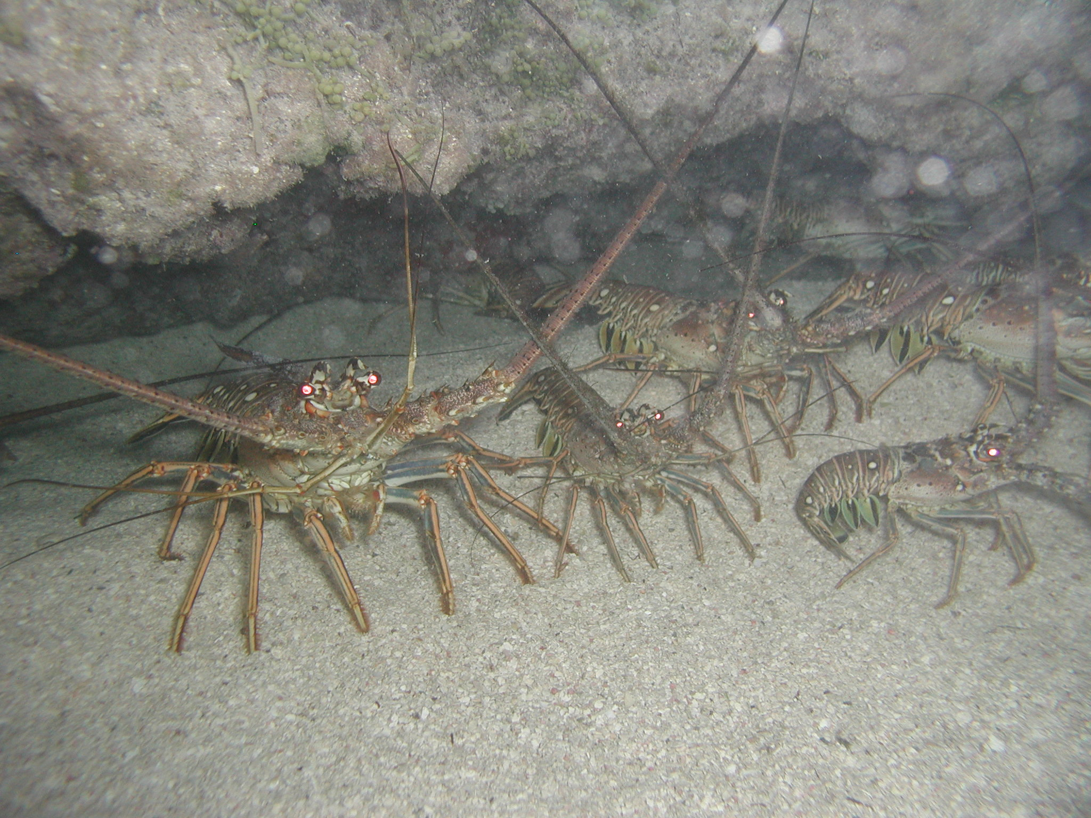
long conical antennae.

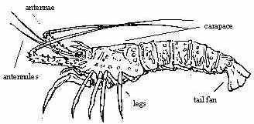

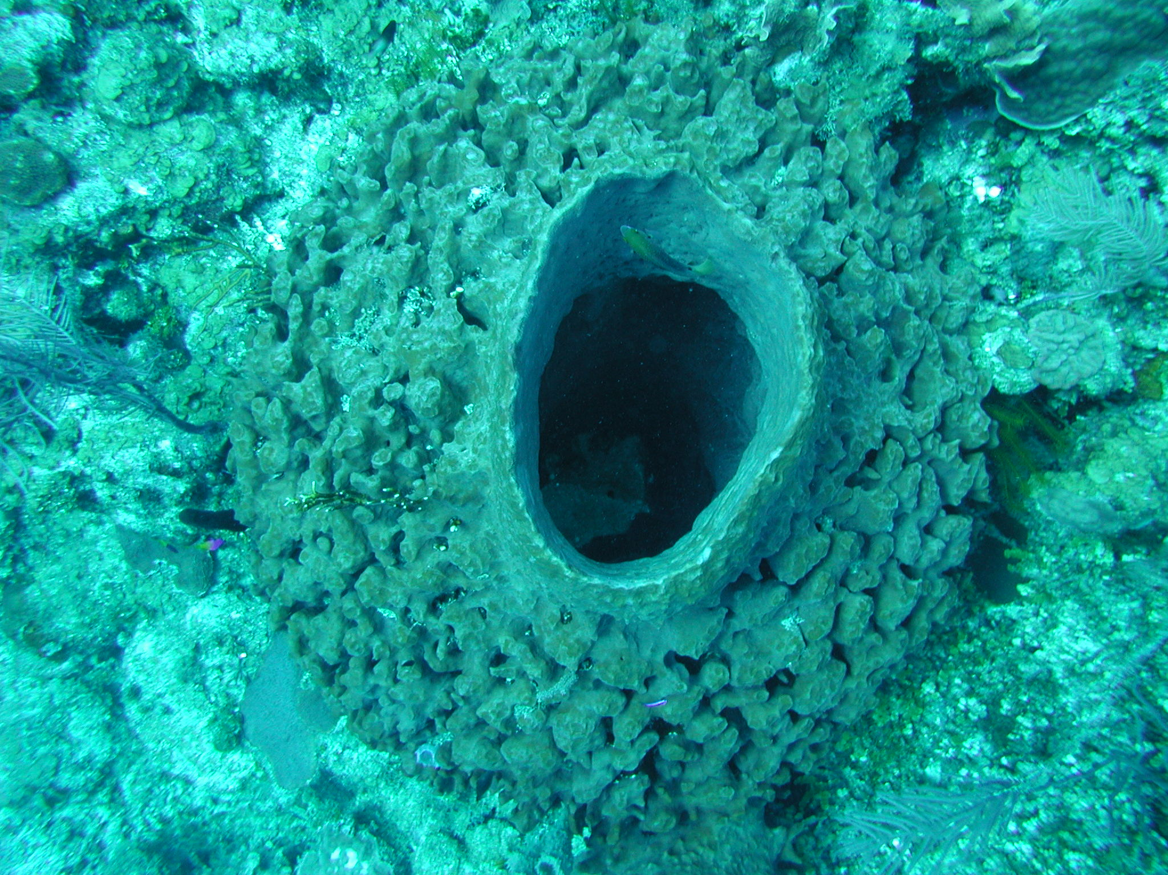

Convoluted Barrel Sponge
Fun Facts:
- Sponges
formed over 500 million years ago.
- Sponges filter
water through their bodies digesting organic particles.
Aplysina lacunosa

Size: 1-3 feet

Depth: 60-130 feet

Visual Aid: Massive, thick-walled barrels or tubes.
deeply convoluted and pitted exteriors. Grow
solitary or in small groups.
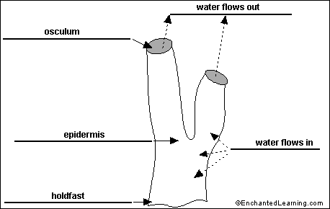

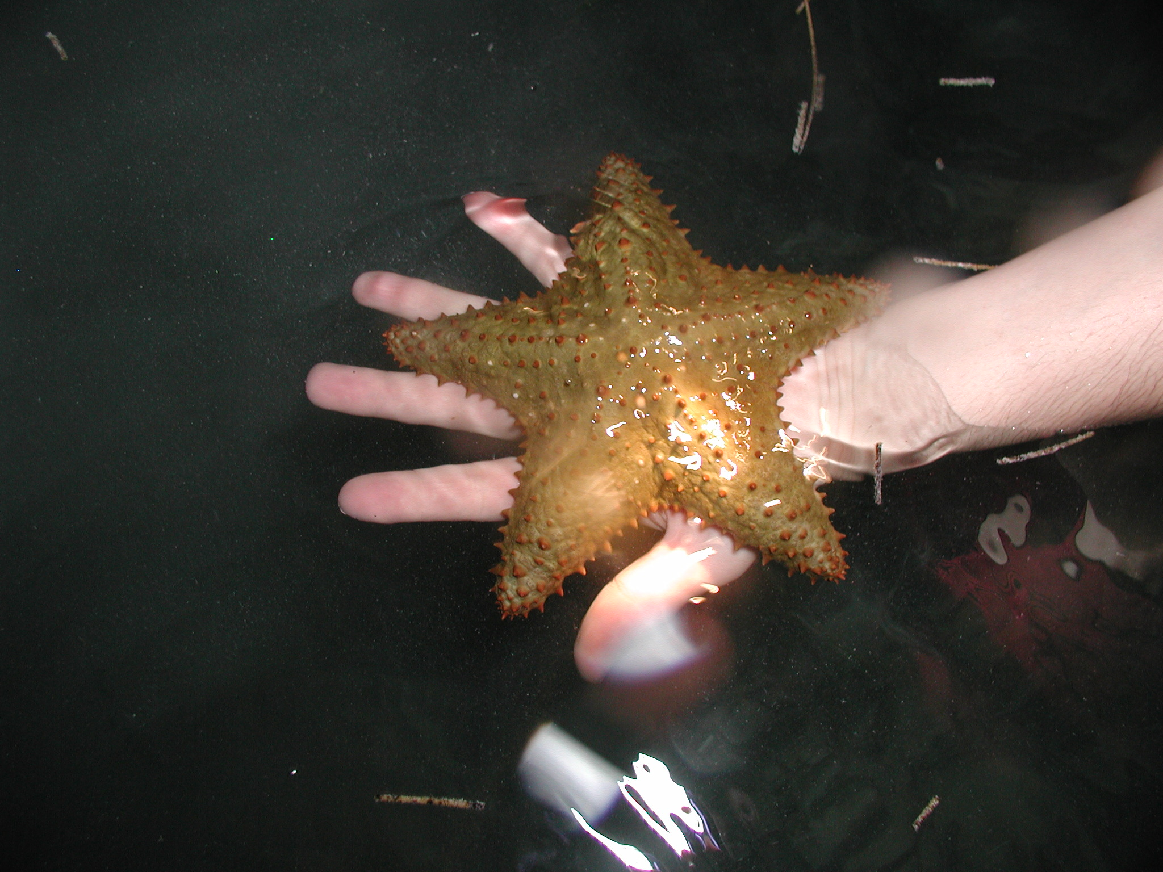

Cushion Sea Star
Fun Facts:
- Sea stars are well
known for their ability to regenerate.
- Sea stars are
carnivores and have no
hard mouth parts to help them capture prey.
- Sea stars do not
have a brain.
Oreaster reticulates

Size:
8-14 inches
Depth:
5-35 feet

Visual Aid: Thick, short arms and
heavy body with knobby spines form
net-like geometric design. Color is
orangish-brown to tan. Juveniles
are green.
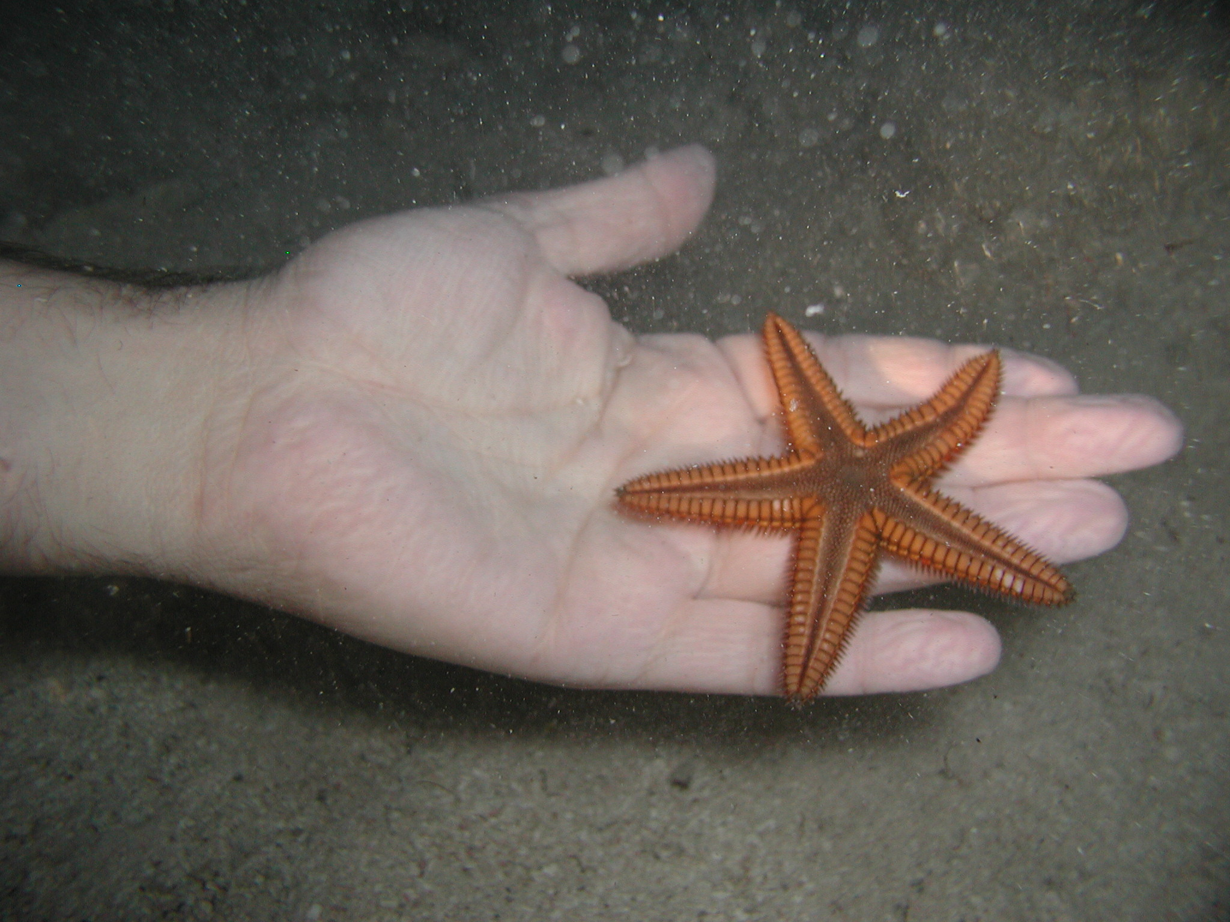
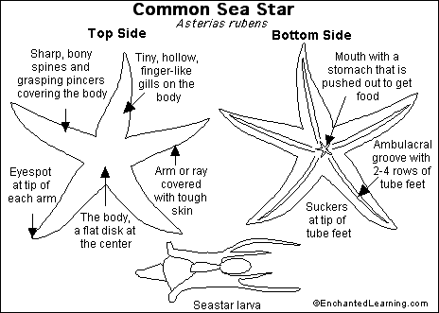

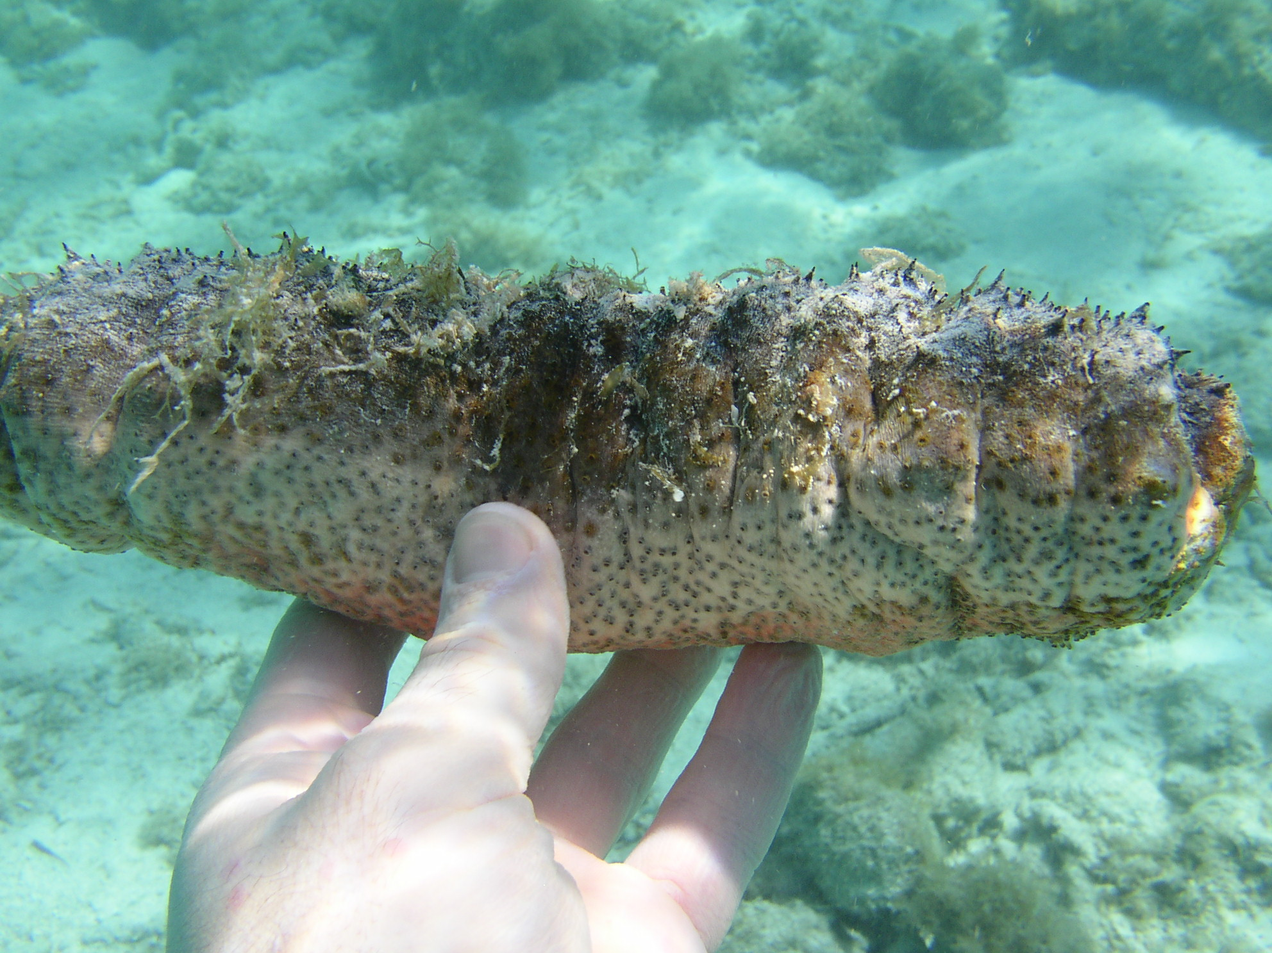

Donkey Dung Sea Cucumber
Fun Facts:
- This
common sea cucumber’s appearance makes it easily identifiable.
- Although the
donkey dung sea cucumber may appear defenseless, its skin contains toxins.
- Although it lacks
spines and arms the donkey dung sea cucumber is an echinoderm.
Holothuria mexicana

Size:
10-14 inches
Depth:
10-60 feet

Visual Aid: Dark gray to black
color with deep creases. Vent is
rose to white color with scattered,
small brown podia.

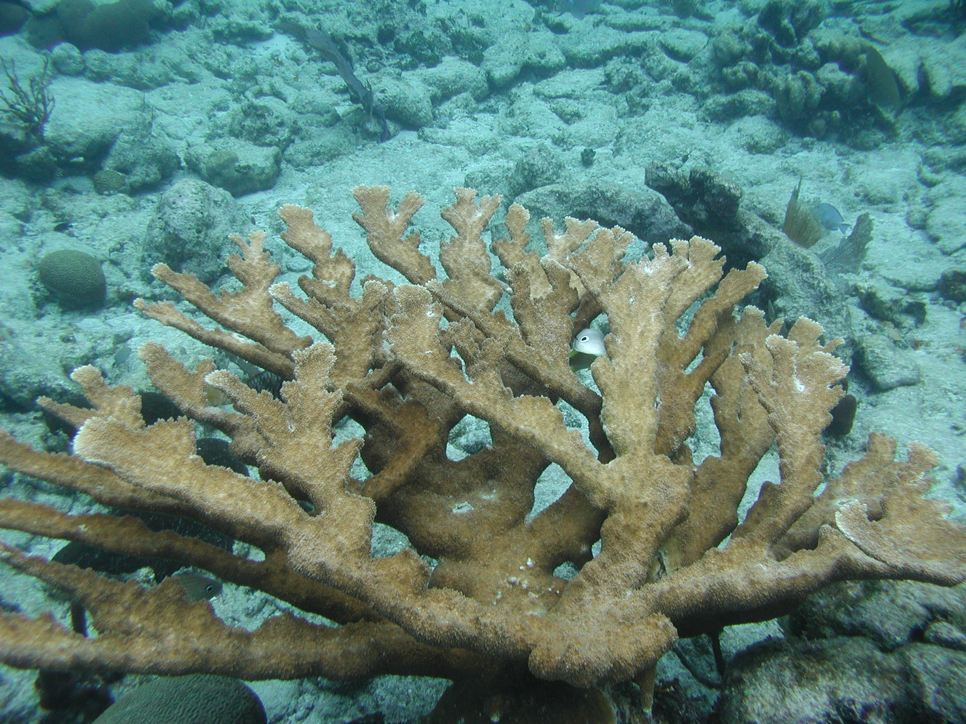

Elkhorn Coral
Acropora palmate
Size
Fun Facts:
- One of the
characteristic species living in the shallow fringing reefs off Belize’s cayes.

Colonies from 1 -8 feet

Depth
Shallow waters with good
water movement and wave action

Visual Aid:
Branches are flattened like moosehorns
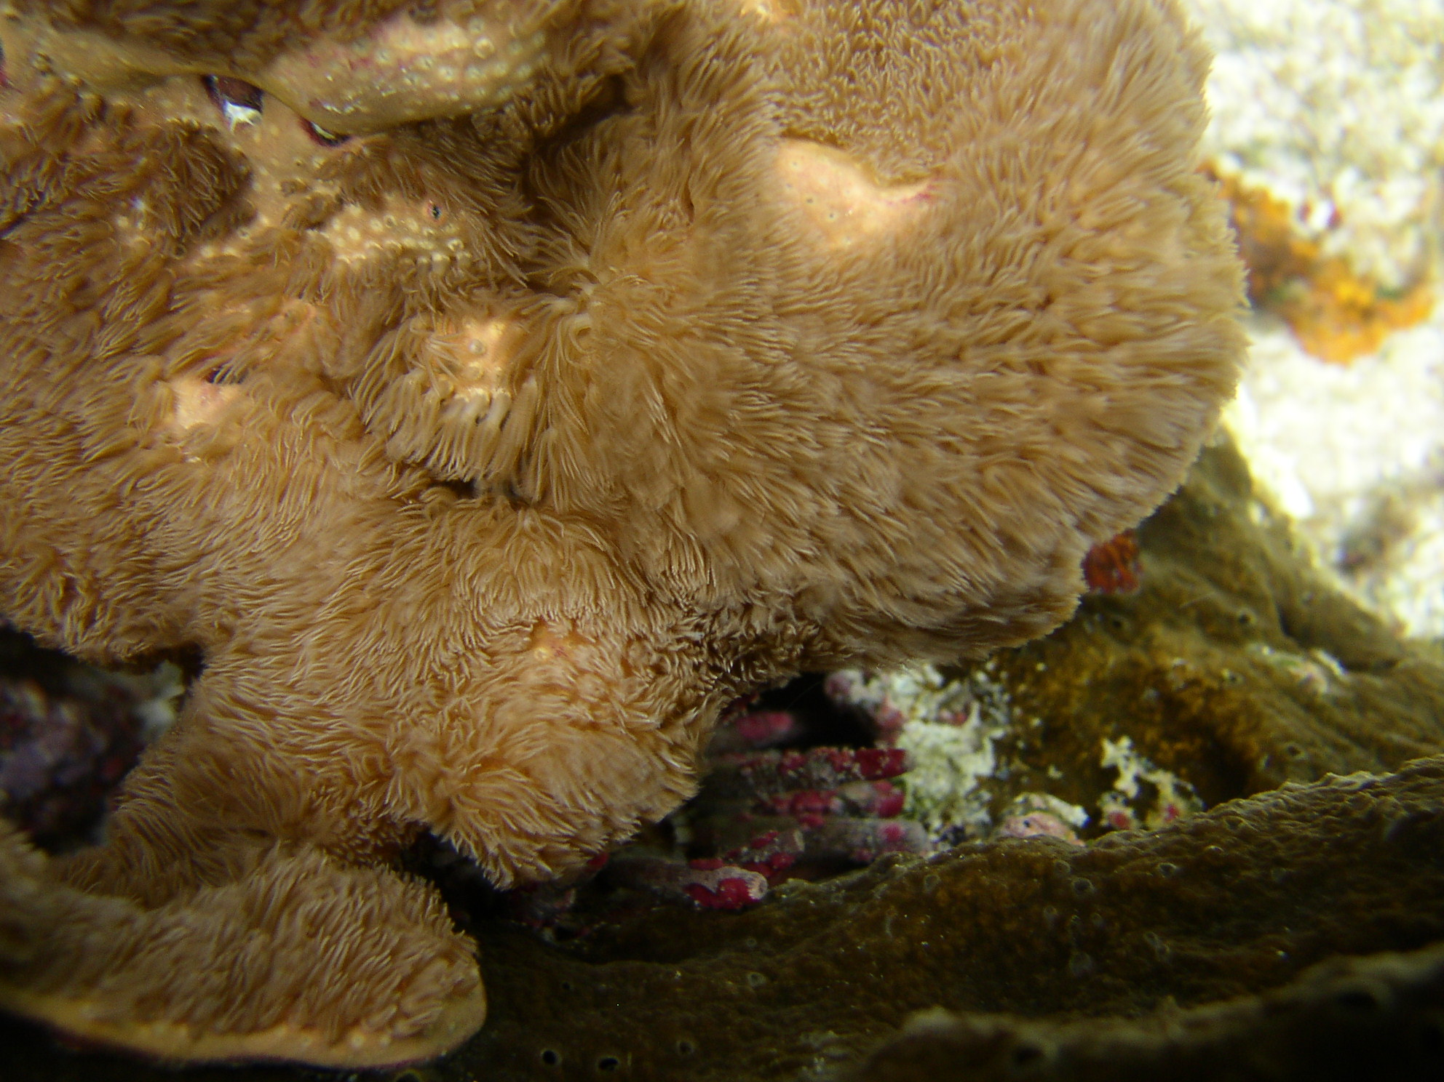

Encrusting Gorgonian
Erythropodium caribaeorum

Size
Fun Facts
- The “hairs” will move in unison with the currents.
Grows in large mats

Depth
Prefers shallow water

Visual Aid
When polyps are retracted it looks
like oozing leather. When polyps are
extended they look like dense hair and move
in unison with the currents.

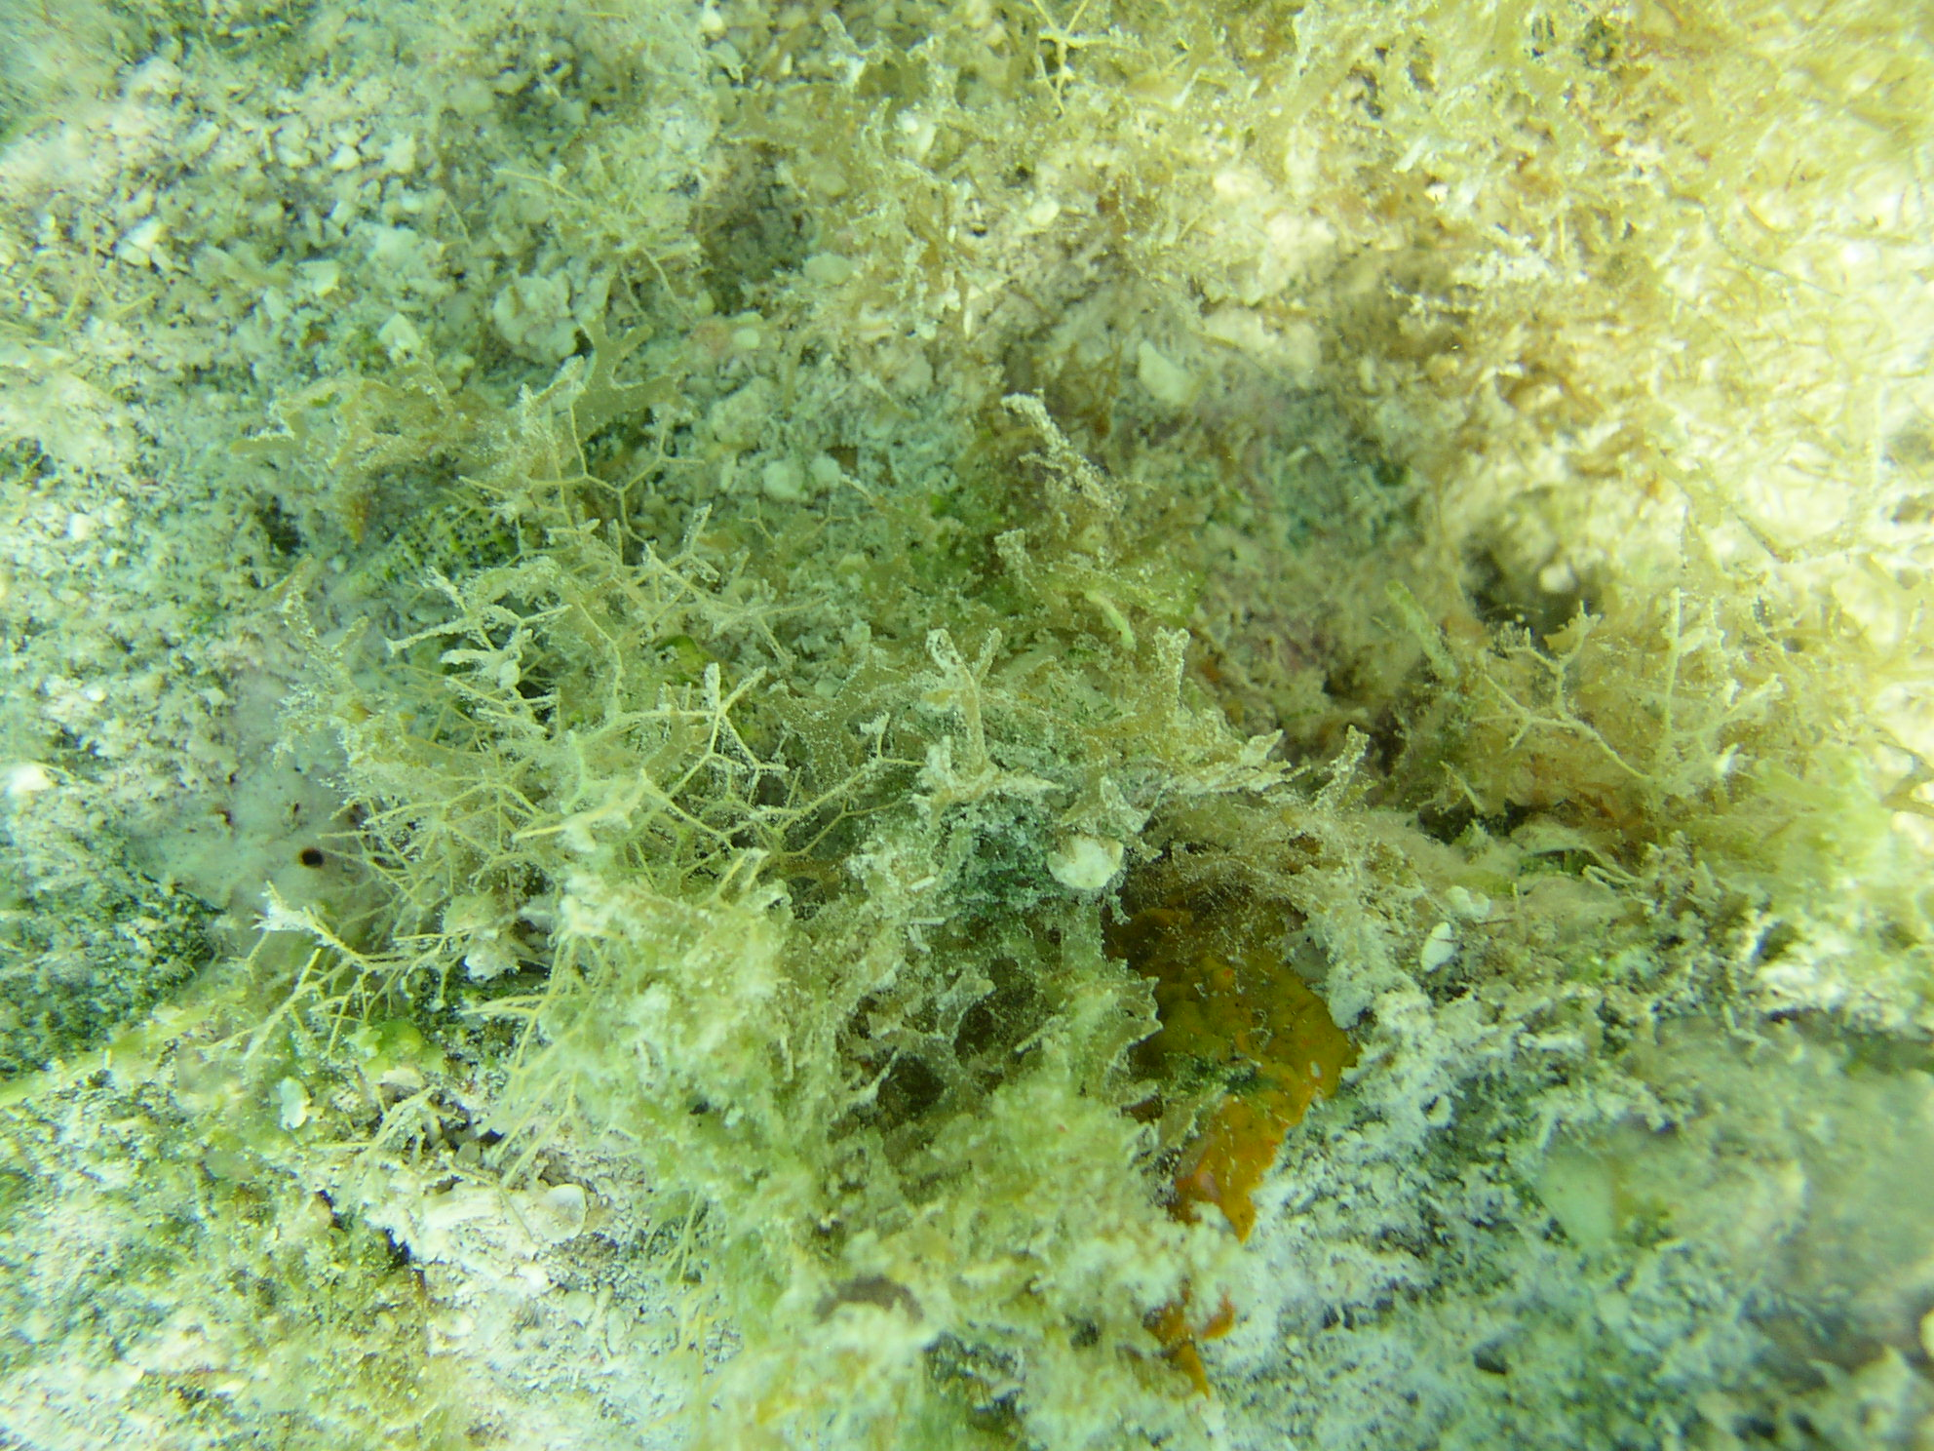

Feather Bush Hydroid
Dentitheca dendritica

Size: 8-12 inches
Fun Facts:
- Will sting the
bare skin of humans.

Depth: 30-130 feet

Visual Aid: Bush-like colony of stout central
stalks and numerous angular primary branches
and sub-branches.

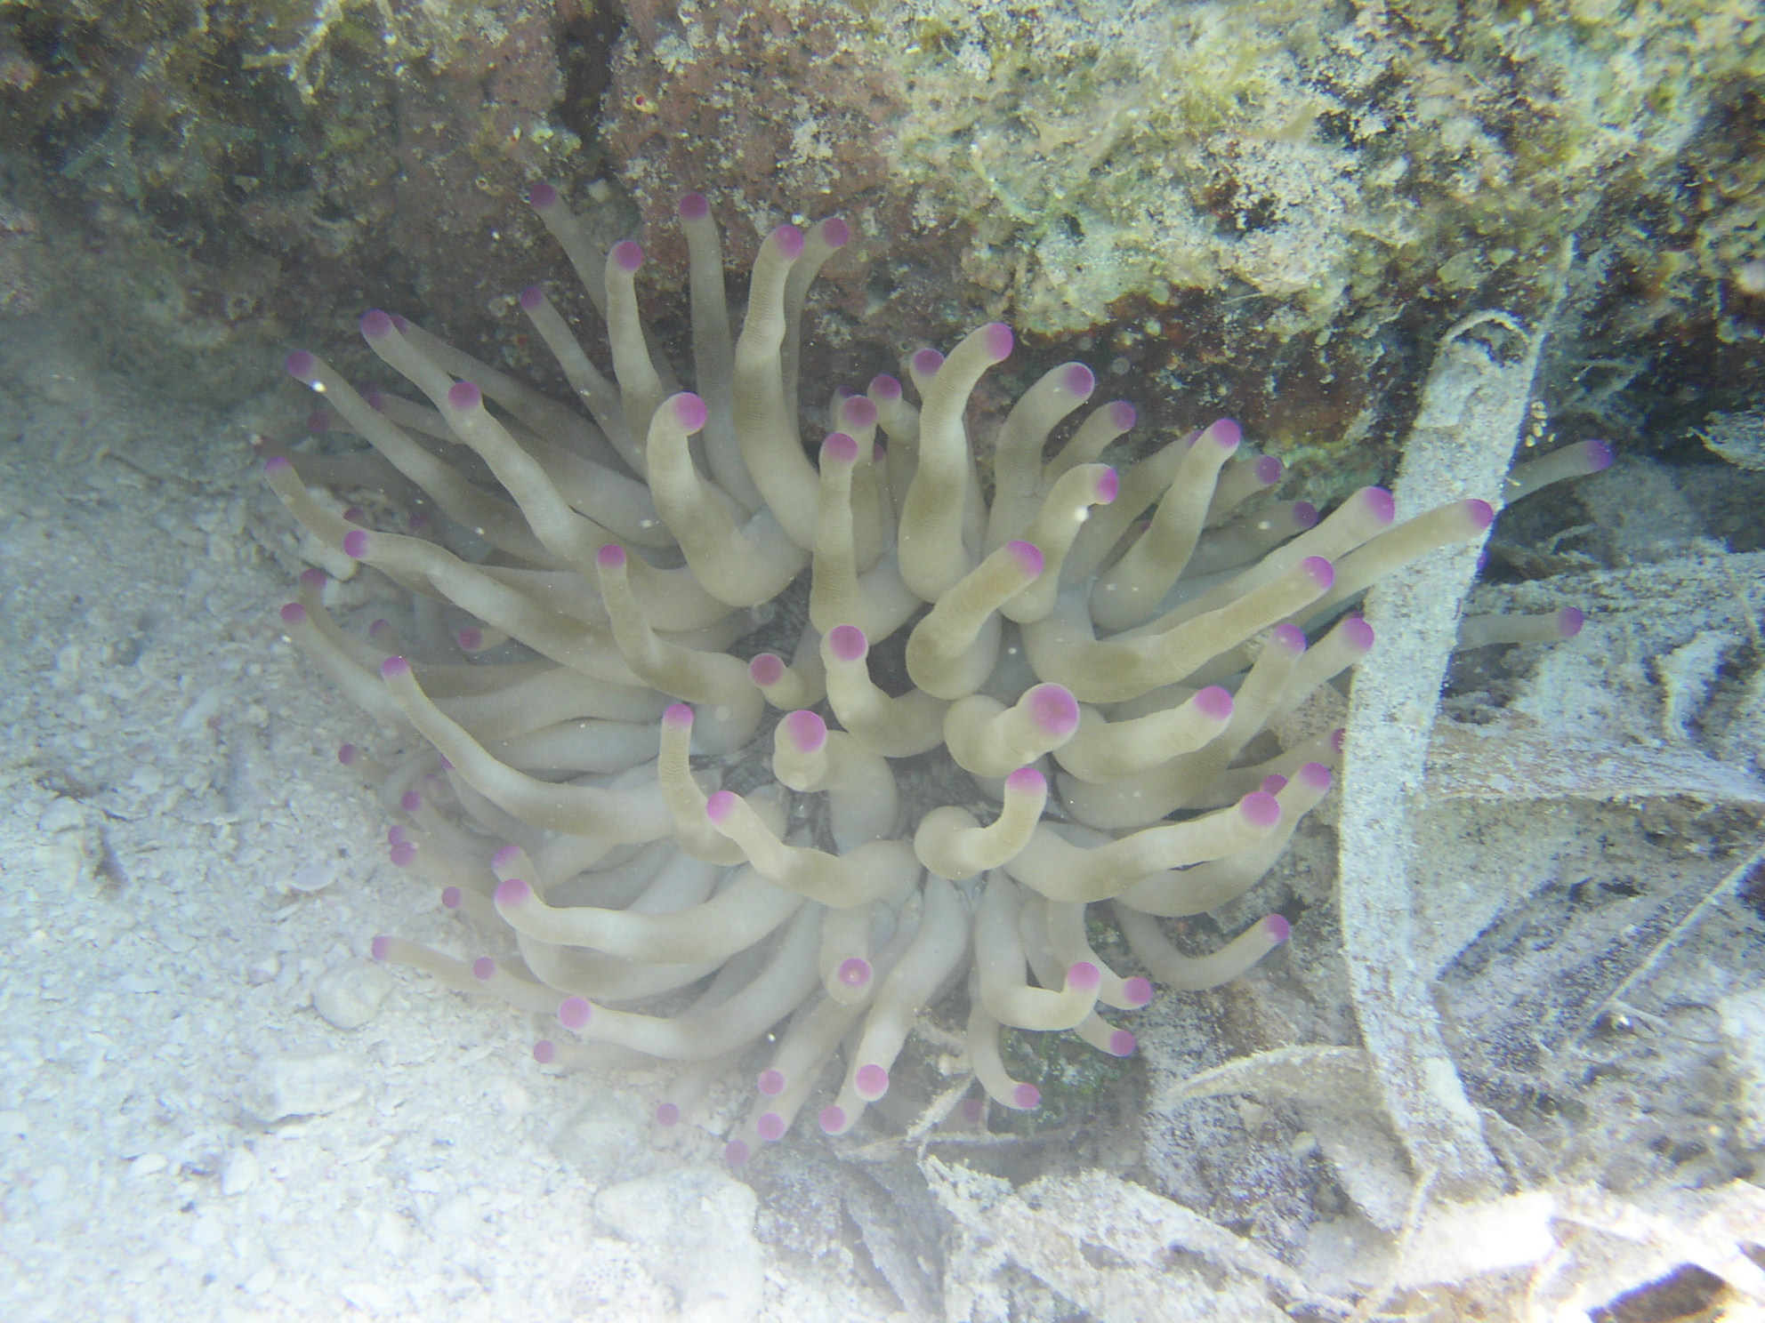

Giant Anemone
Condylactis gigantean
Fun Facts:
- The largest anemone
species in the Caribbean.
- Cleaner shrimp use
this anemone as a refuge.
- This anemone, like
others, uses stinging cells called nematocysts to kill their prey.

Size:
6-12 inches across tentacles and body
Depth:
15-100 feet

Visual Aid:
Tentacles and body white,
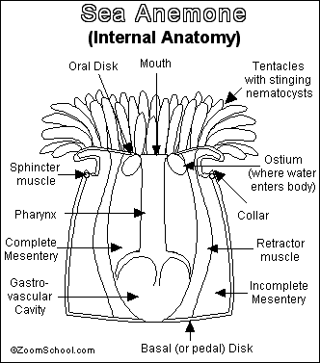
often with tints of gray, brown,
yellow and green. Tentacles are
long with slightly enlarged tips that
may be pink, lavender,
yellow, chartreuse or white.
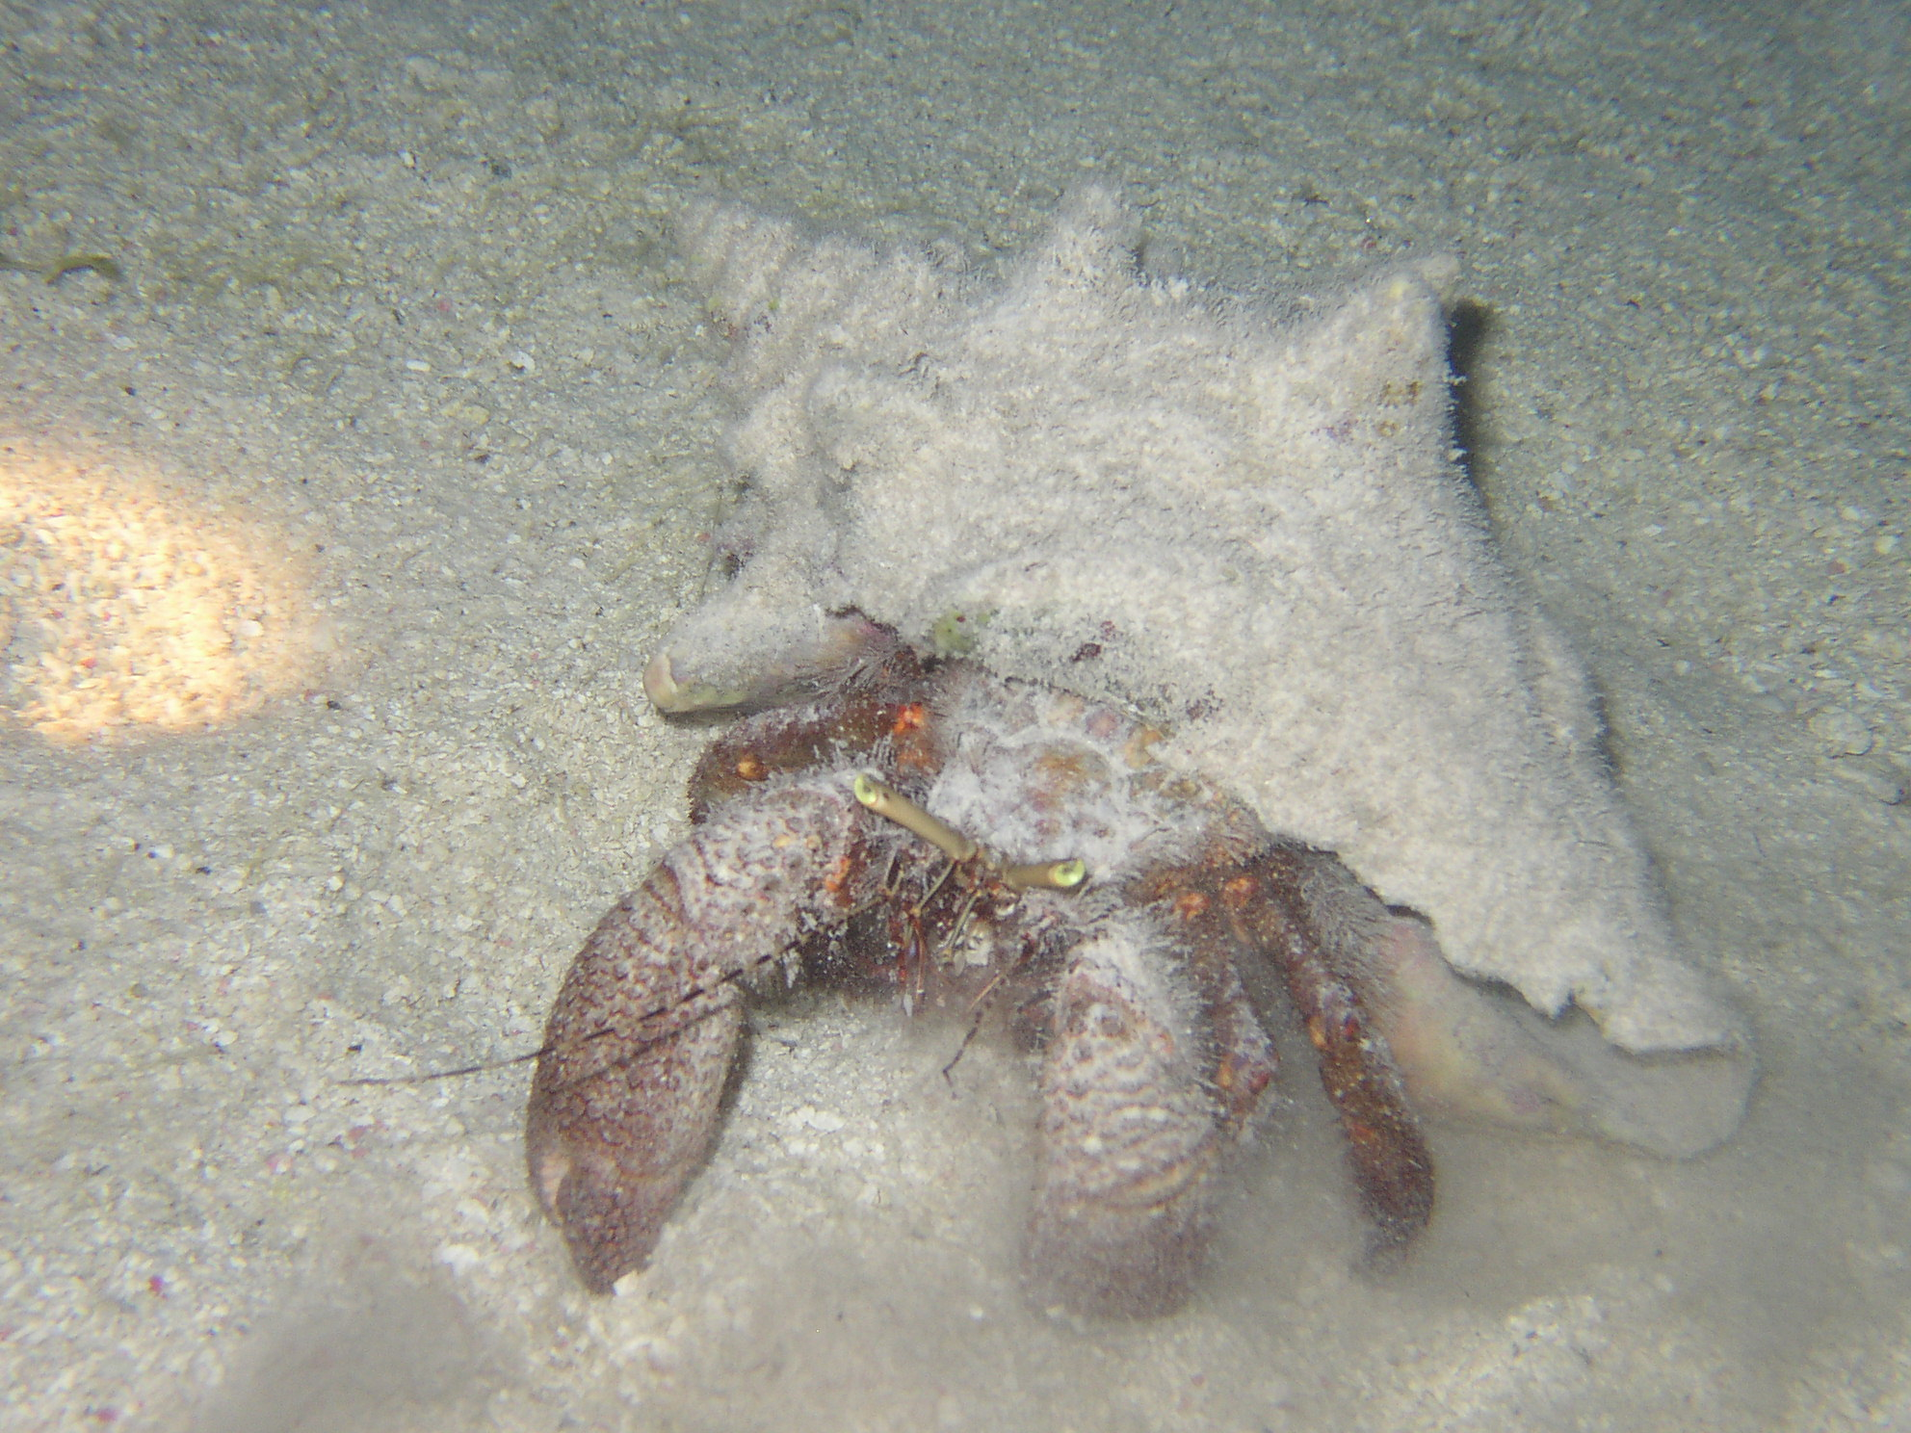

Giant Hermit Crab
Fun Facts:
- Giant hermit crabs
produce a loud clicking sound when confronted and they pull back into their shell.
- The giant hermit
crab is the largest Caribbean hermit crab.
- It is not a true
crab because it relies on other animals old shells for protection.
Petrochirus diogenes

Size:
5-8 inches 12 inches max
Depth:
3-100 feet

Visual Aid: They have large lavender-gray
to reddish-brown claws with a surface texture
of irregular overlapping scales. Their antennae are
banded red and white. Eyes can be either green
or blue-green.
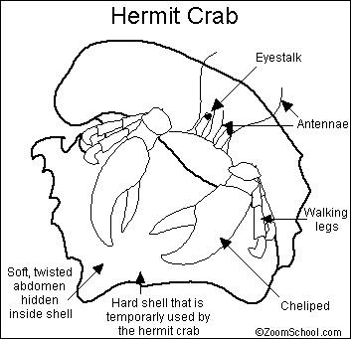

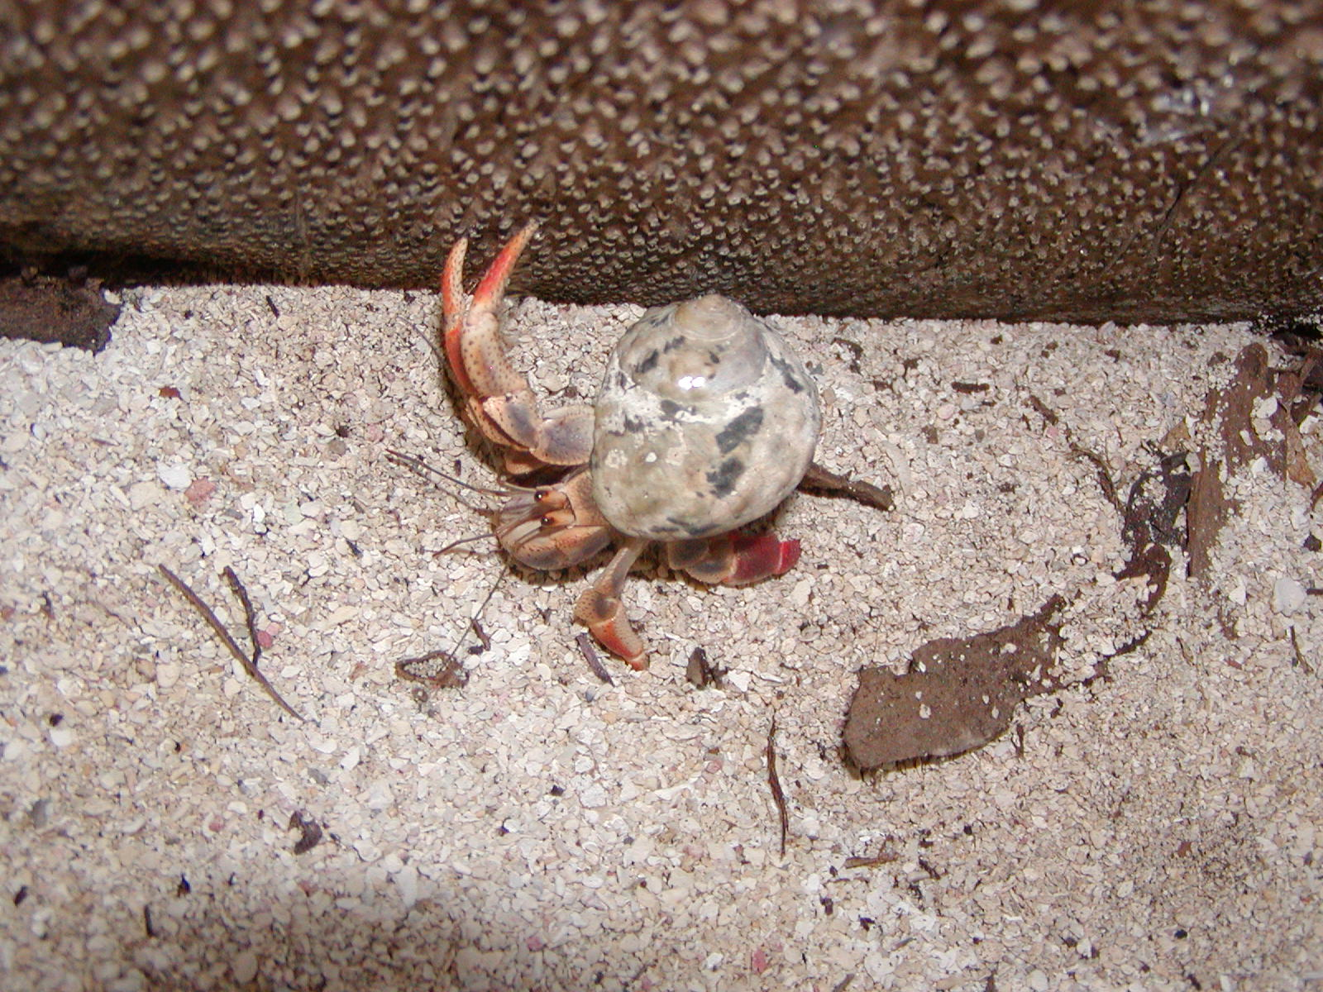

Land Hermit Crab
Fun Facts
- People keep these animals as pets in the US
- They change their shells as they grow.
Coenobita clypeatus

Size
1 1/2" (38 mm) long, 1/2" (13 mm) wide.

Visual Aid
Living in snail shell. Nearly cylindrical. Reddish
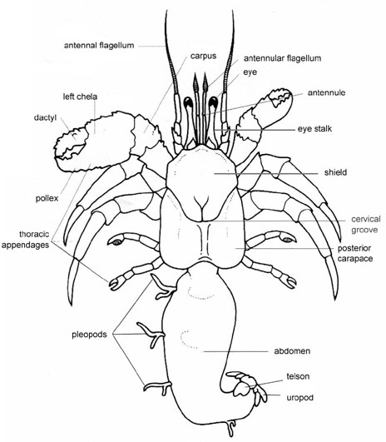
or purplish-brown, pincers purple or bluish
with orange tips, beak and mouth parts yellowish.

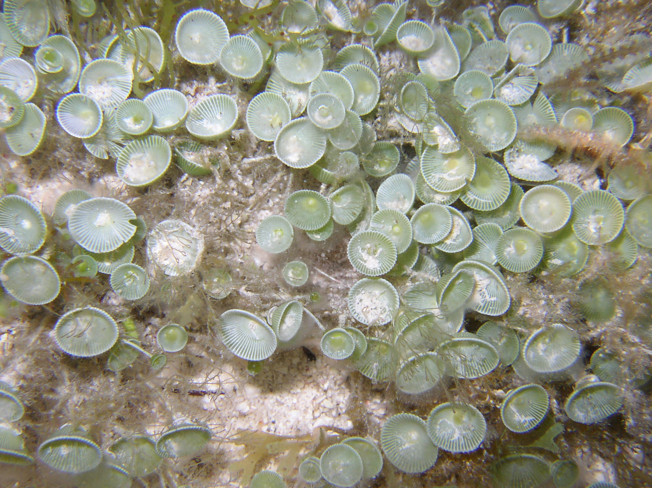

Mermaid’s Wine Glass
Acetabularia crenulata
Fun Facts:
- This plant is actually all one cell.
- This is a type of green algae.

Size
Up to 5 cm in height
Depth
Found in shallow sheltered waters
Visual Aid
A thin stem with a “wineglass” top.

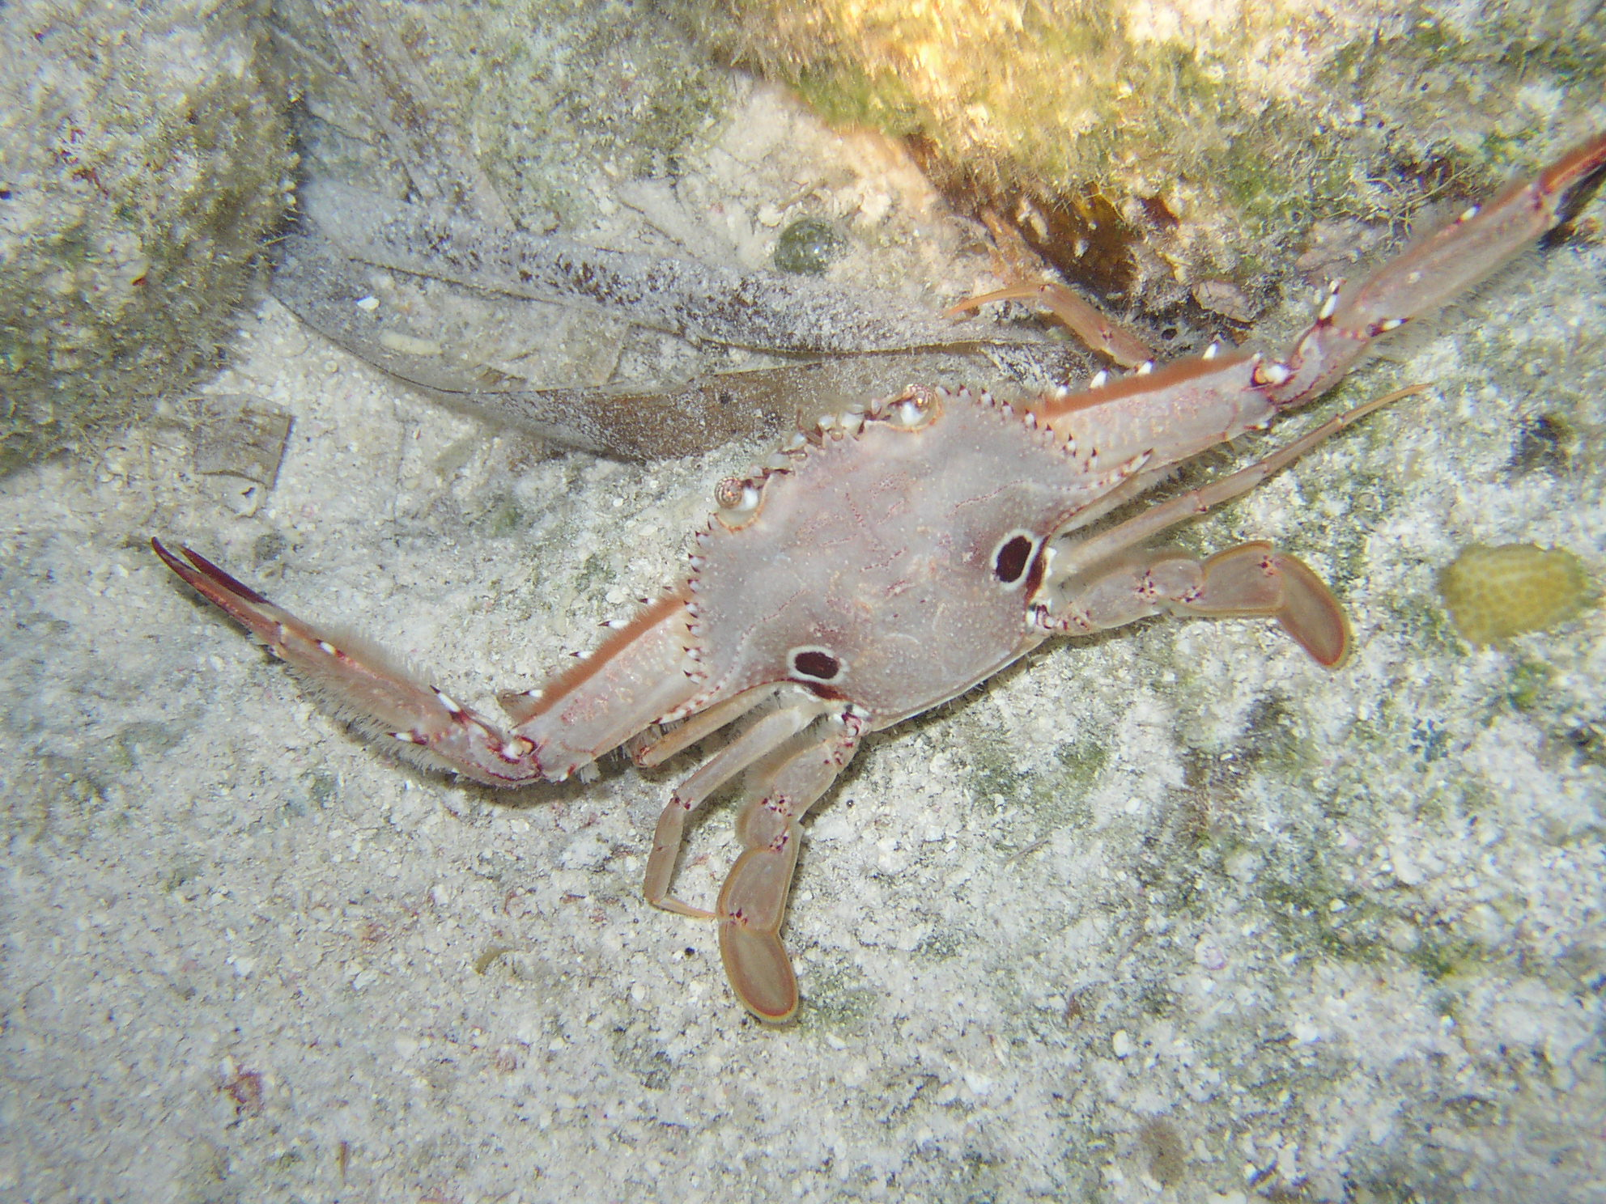

Ocellate Swimming Crab
Fun Facts:
- Rear pair of legs have developed into paddle-like appendages which are used for swimming.
- The ocellate crab gets its name from the spots on its back, ocellate means having spots or resembling eyes.

Portunus sebae

Size:
2.5-3.5 inches
Depth:
15-90 feet

Visual Aid:
Brown to tan with two large,
dark reddish-brownspots ringed
in white on rear of carapace.
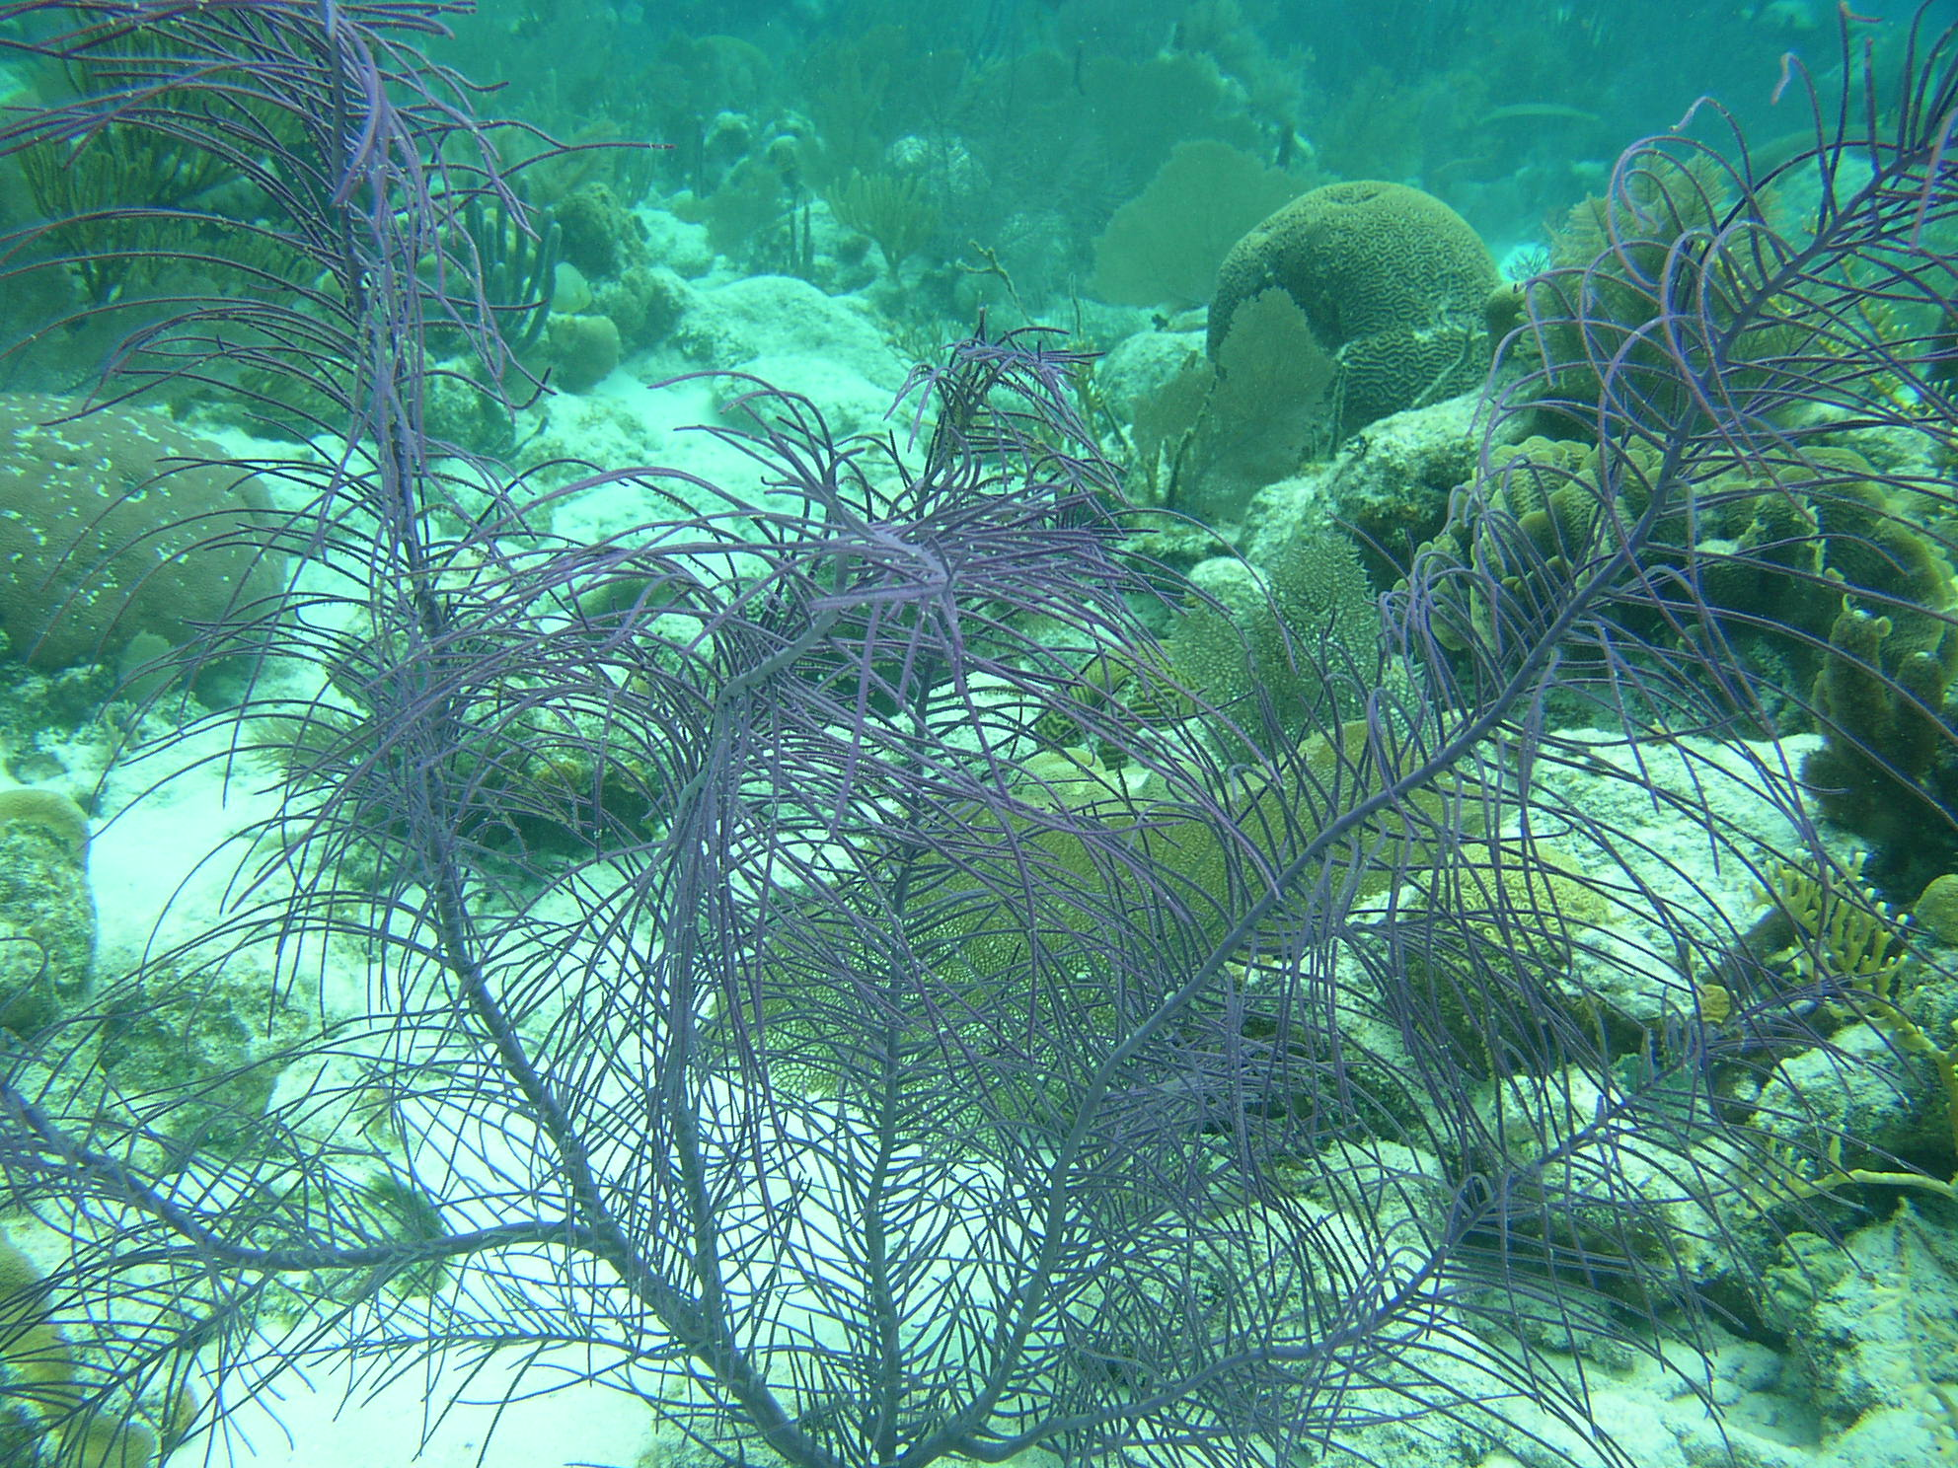

Sea Plumes

Fun Facts:
- Must have
zooxanthellae to feed on.

Size
1-7 feet

Depth
2-120 feet

Visual Aid:
These are very common.
Clusters of feather-like plumes.
Tall branching colonies.
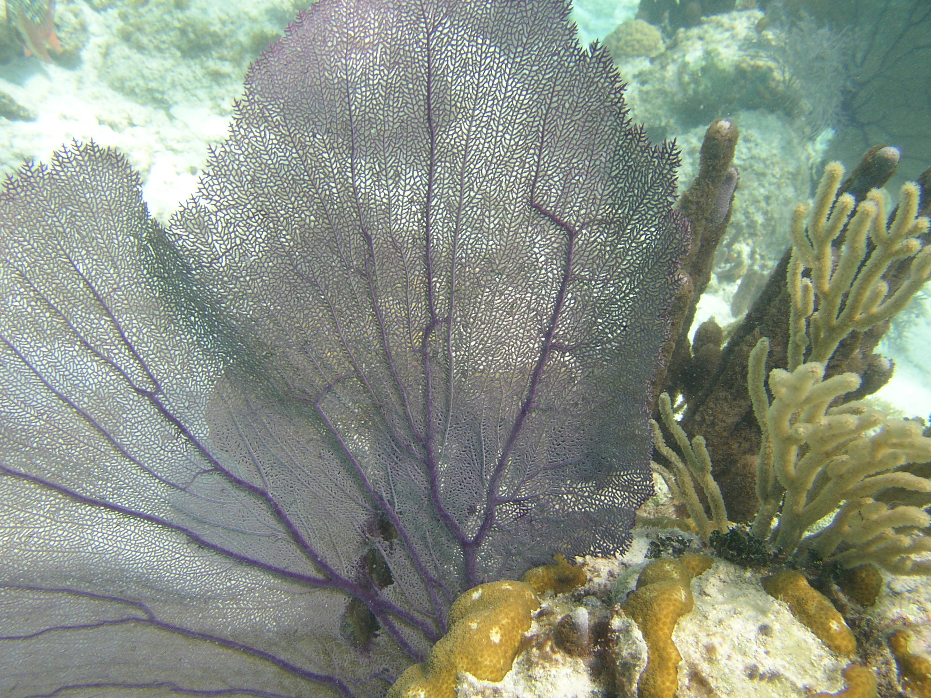

Seafan Hydroid
Solanderia gracilis

Size: 6-18 inches
Fun Facts:
- Will sting the
bare skin of humans. Suprising is it not!?

Depth: 15-80 feet

Visual Aid: Reddish to purple stalk is
heavily branched and lined with thin,
short, polyp-bearing, whitish branches,
all on a single plane.

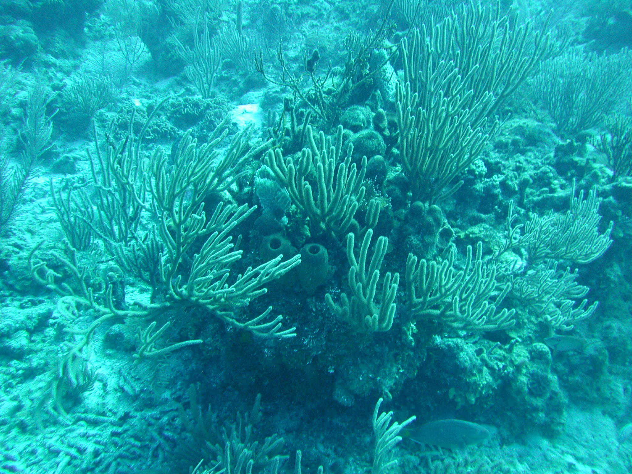

Spiny Sea Rods
Plexaurella sp.

Size: 4-18 inches
Fun Facts:
- This coral has a very
pliable proteinaceous compound called Gorgonin or possibly a calcareous compound, is covered with tissue.
- Animals, such as the
Flamingo Tongue, enjoy eating this coral.
- If the main stem
is not attached to some form of substrate, the entire specimen could deteriorate rather

Visual Aid: Common on patch reefs.
Branching colony with spiny stems.
Tan, light brown, or gray

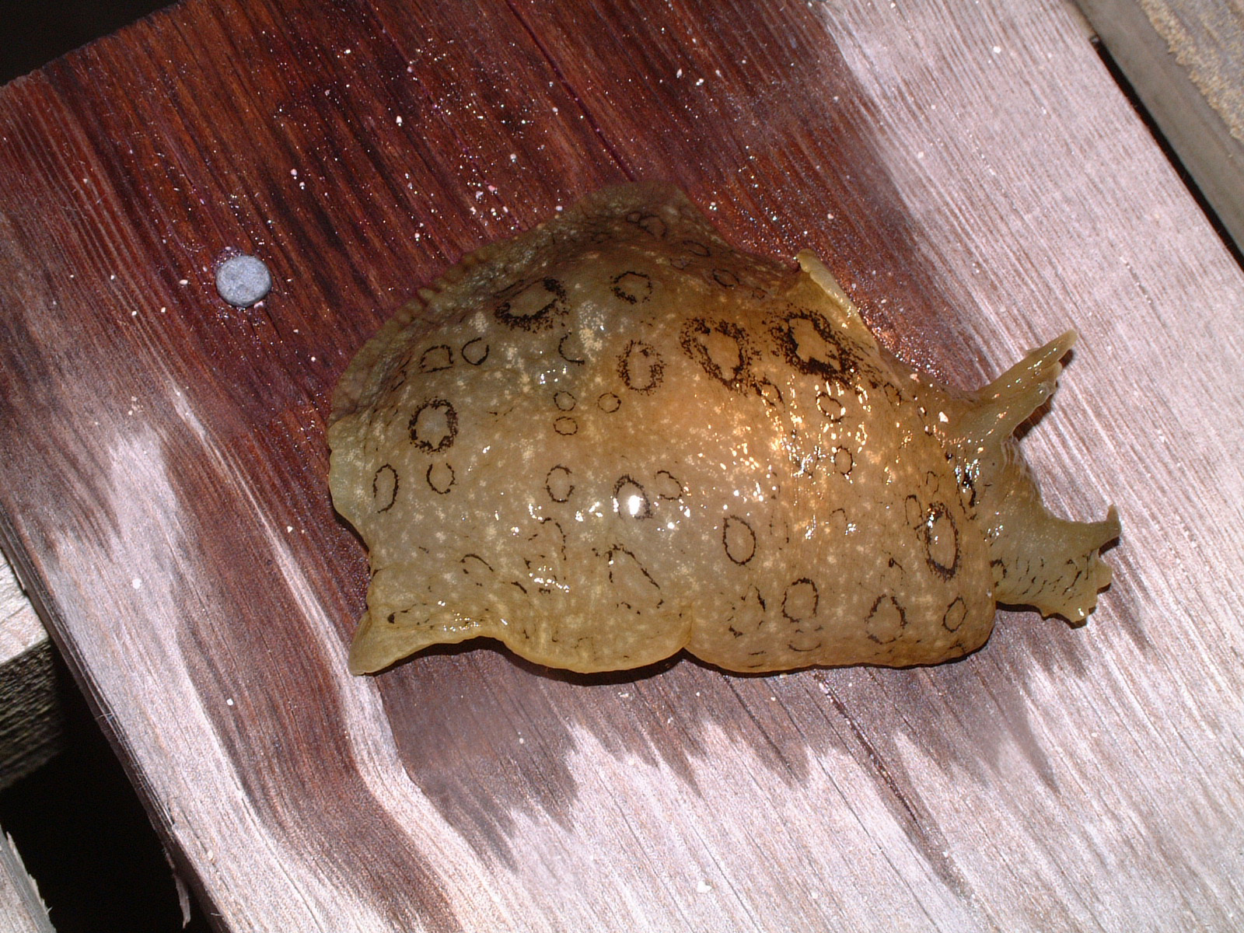
Fun Facts:
- Prefers grassy flats with
scattered rocks.
- When disturbed the sea
hare will discharge a harmless thick purple fluid.
- Sea hares are hermaphroditic, having both male and female reproductive organs and when mating they form chains.
Spotted Sea Hare
Aplysia dactylomela

Size:
3-6 inches 12 inches max.
Depth:
0- 120 feet.
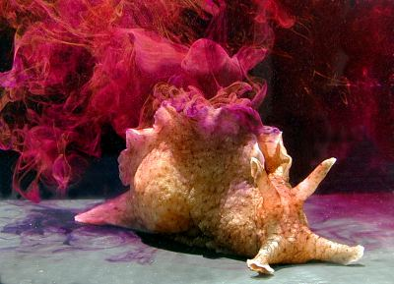
http://www.seaslugforum.net/seahatac.htm Aplysia californica

Visual Aid:
Light brown to green with
irregular light spots
outlined in black.

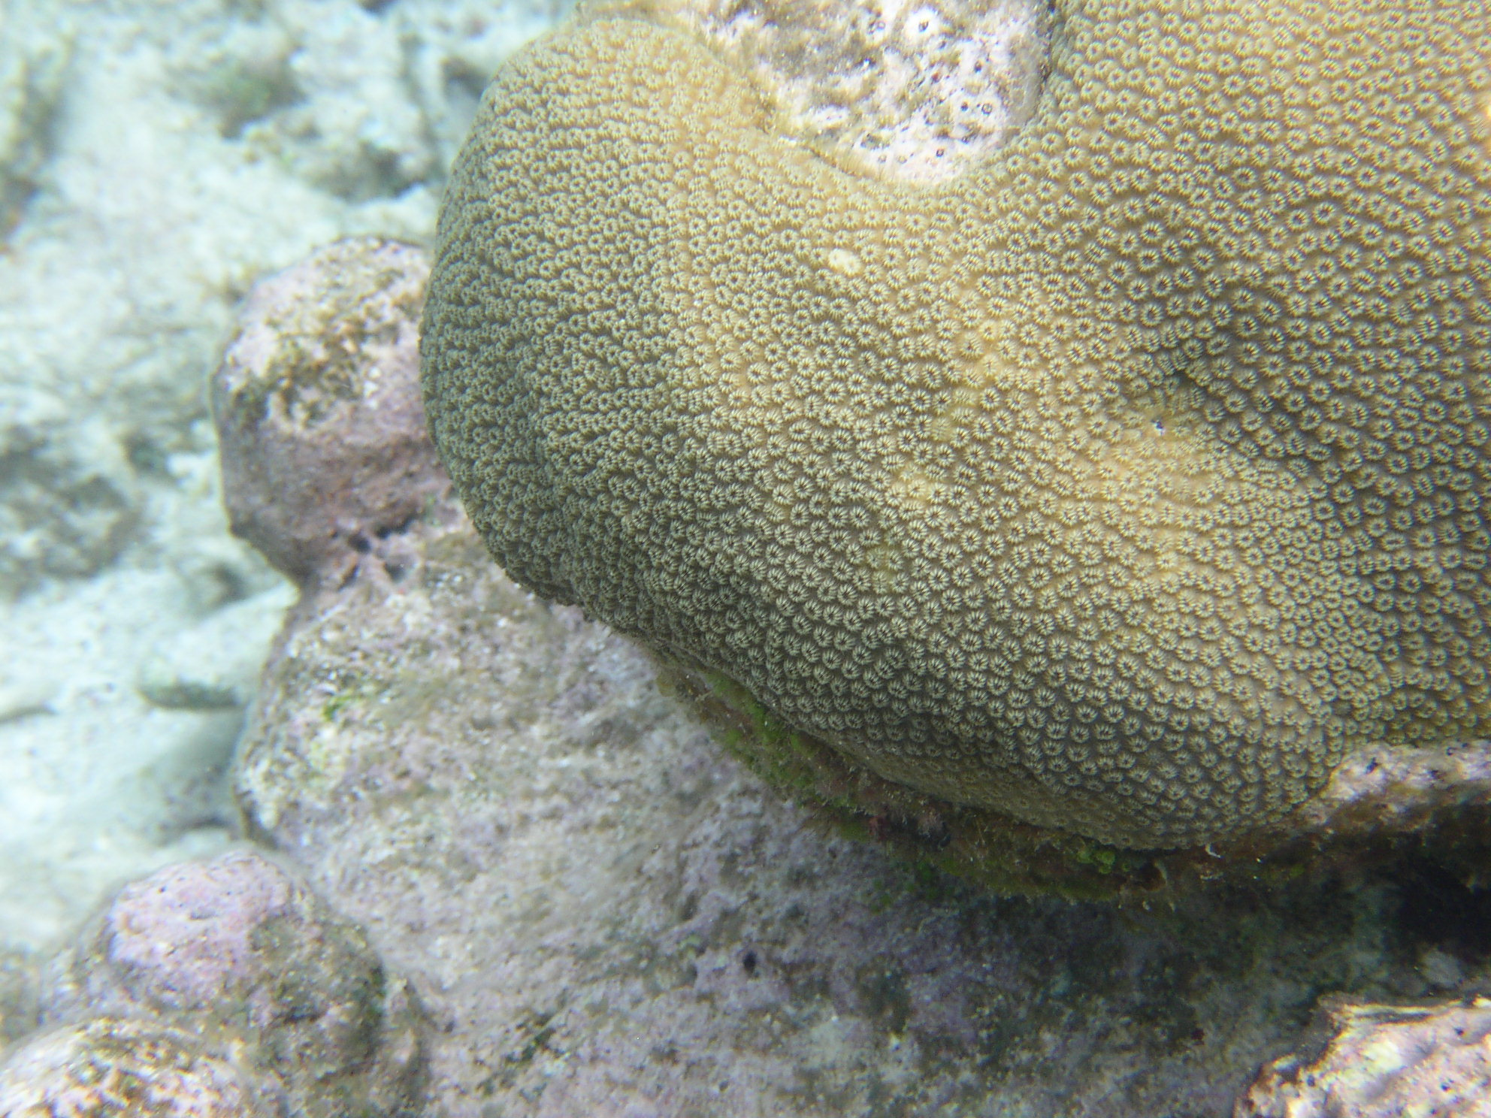

Star Coral
Fun Facts:
- Develops long potent sweeper tentacles at night and can damage nearby corals
Montastrea cavernosa

Size: 2-8 feet

Visual Aid: Huge mounds covered
with blister-like bumps.

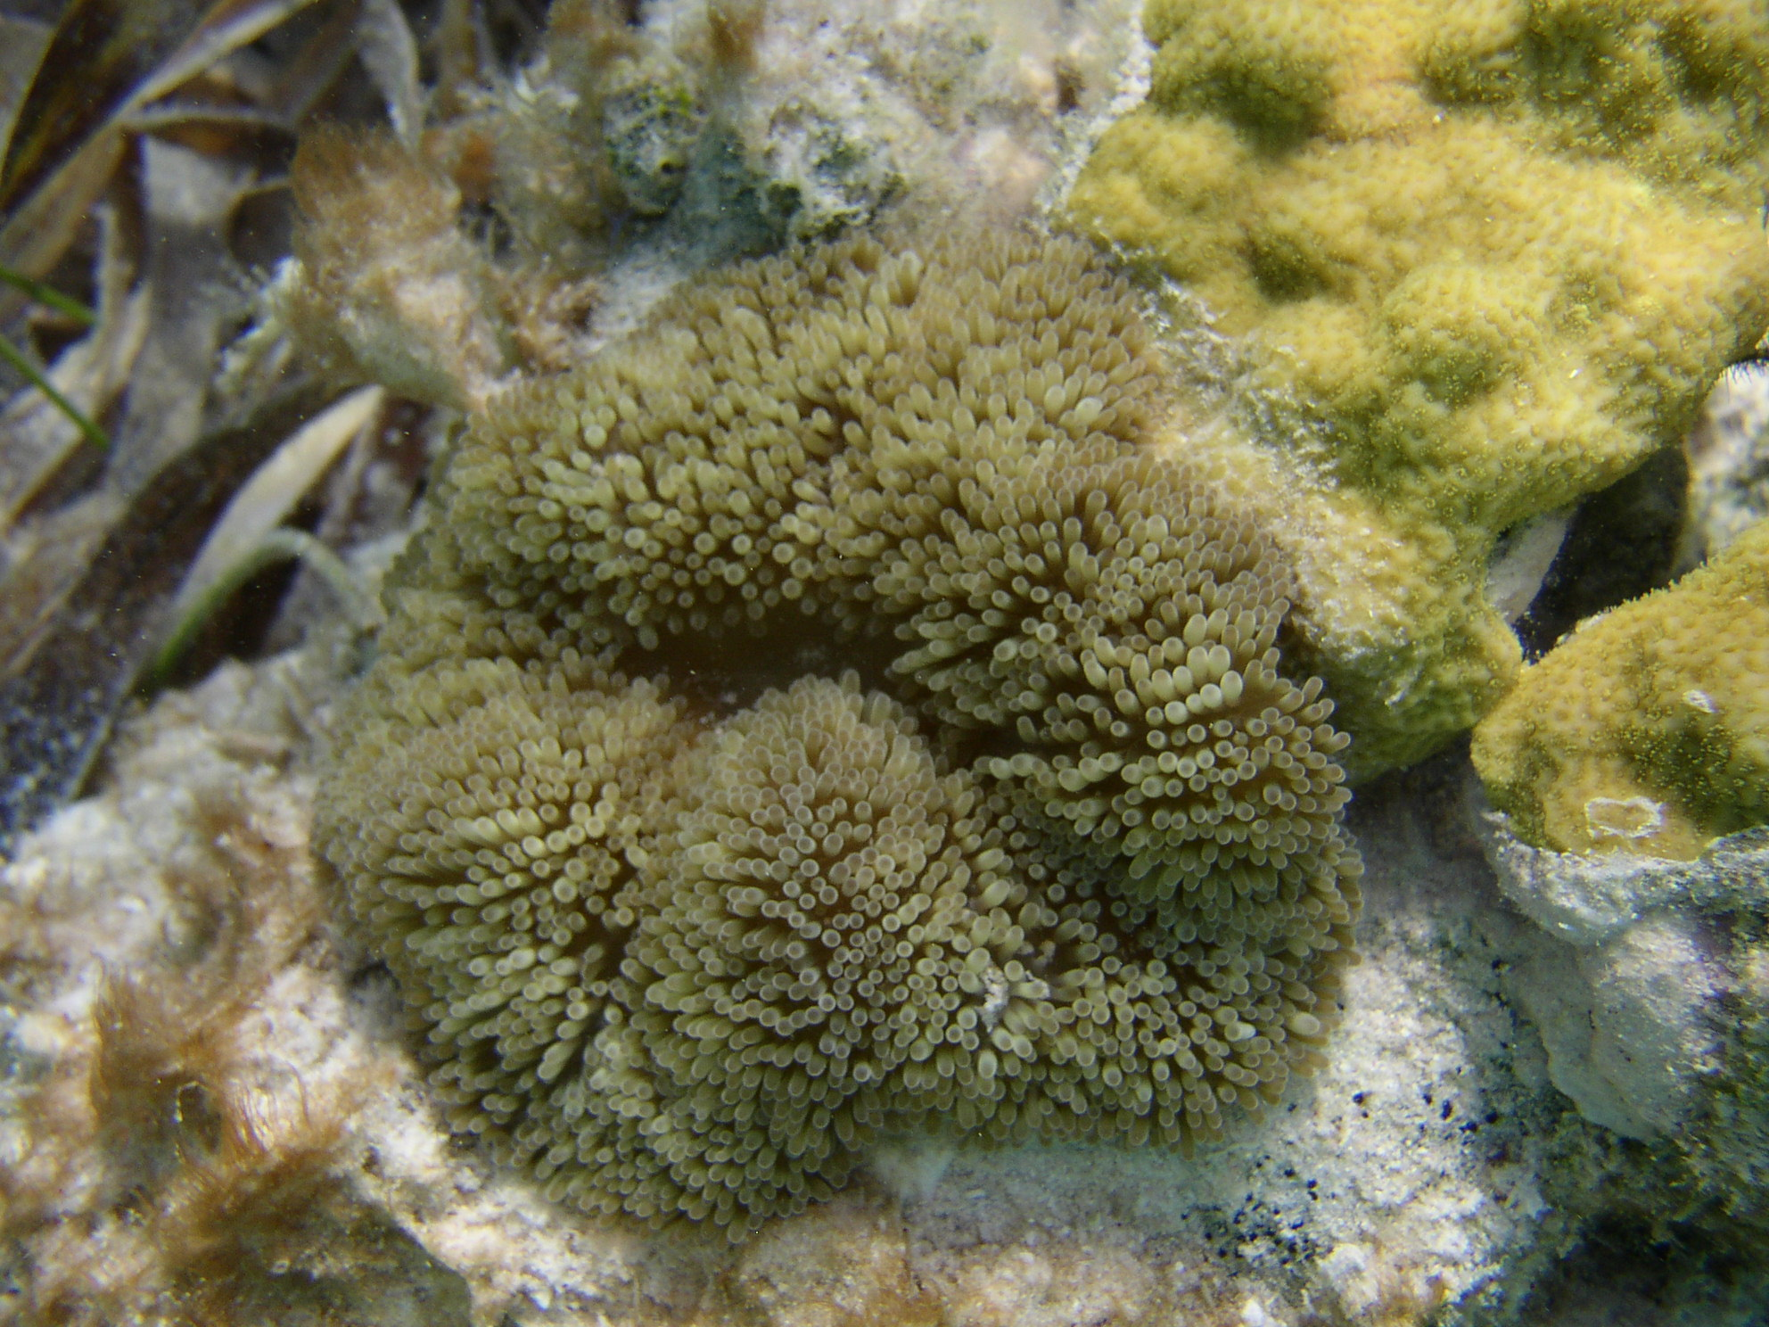

Sun Anemone
Fun Facts:
- Clown fish are
known to live near anemones because they are immune to the toxin the anemones emit.
- The clown fish
form a mutalistic relationship with the anemone; they clean the anemones’ tentacles and scare away predators.
- Tentacles will sting
the bare skin of humans.
Stichodactyla helianthus

Size:
Disc 4-6 inches
Depth:
3-30 feet

Visual Aid: Composed of hundreds of
short, thick tentacles with rounded tips
covering a flattened disc. Tentacles
and disc are green to brown.

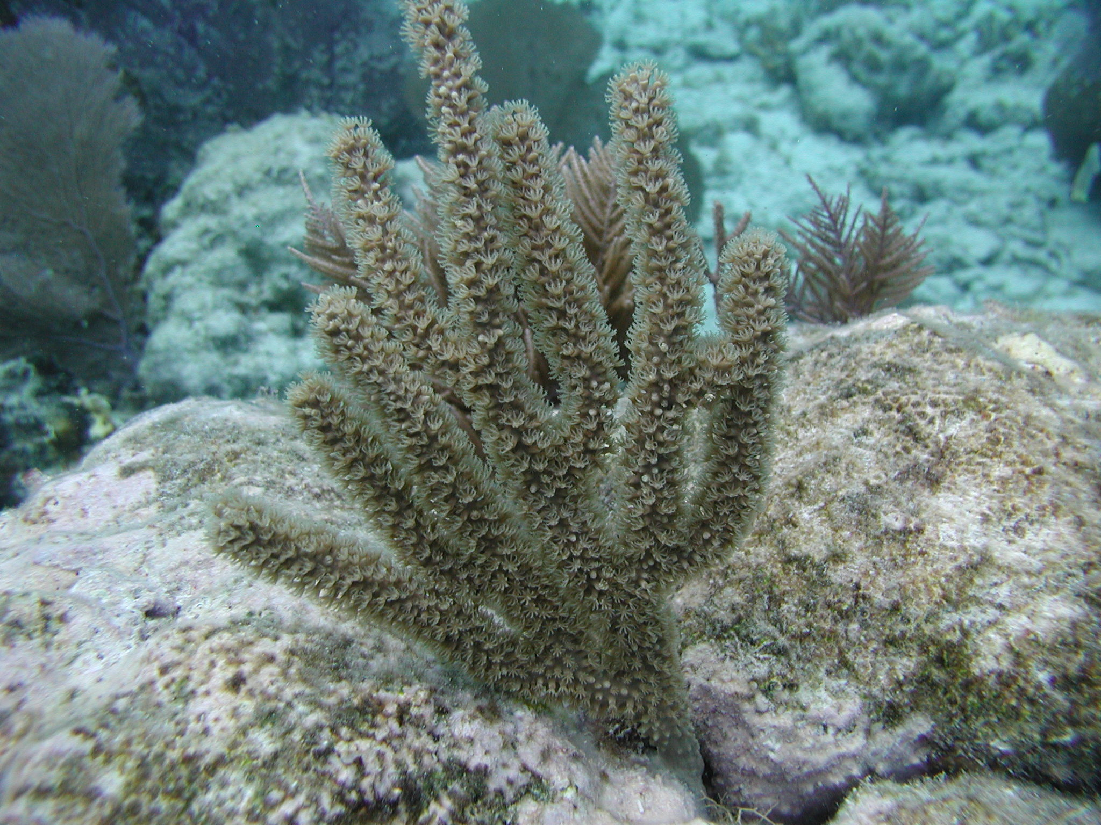

Swollen Knob Candelabrum
Eunicea mammosa
Fun Facts
- Exist in many types of reef environments
- to shallower hardbottom communities
Size
8-12 inches
Depth
In shallow water

Visual Aid
Have tube-like calyces and
candelabra-like colonies. Most are
light gold in color.

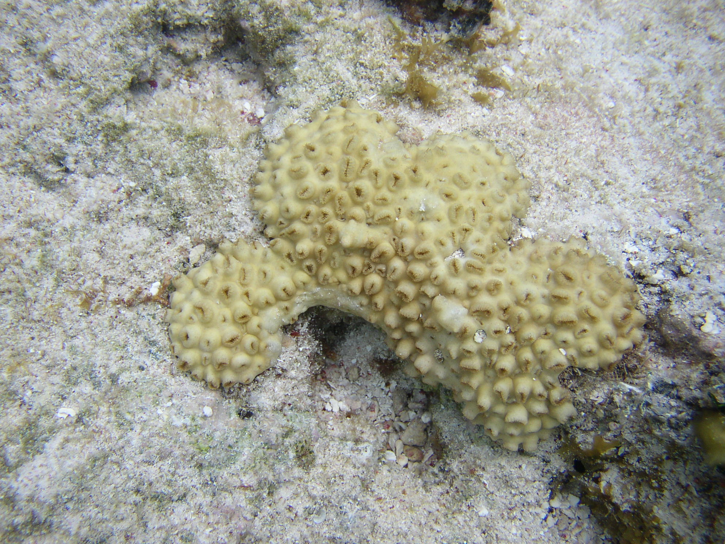

White Encrusting Zoanthid
Palythoa caribaeorum
Fun Facts
- If disturbed tentacles will curl inward and retract.
- The zoanthid is a colony of cnidarians
Size
Disc ¼- ½ inches

Depth
10-40 feet

Visual Aid
Brownish-white colonies form mats
that encrust substrate. Oral discs push
against one another when fully expanded.
Two rings of short tentacles around outer edge.

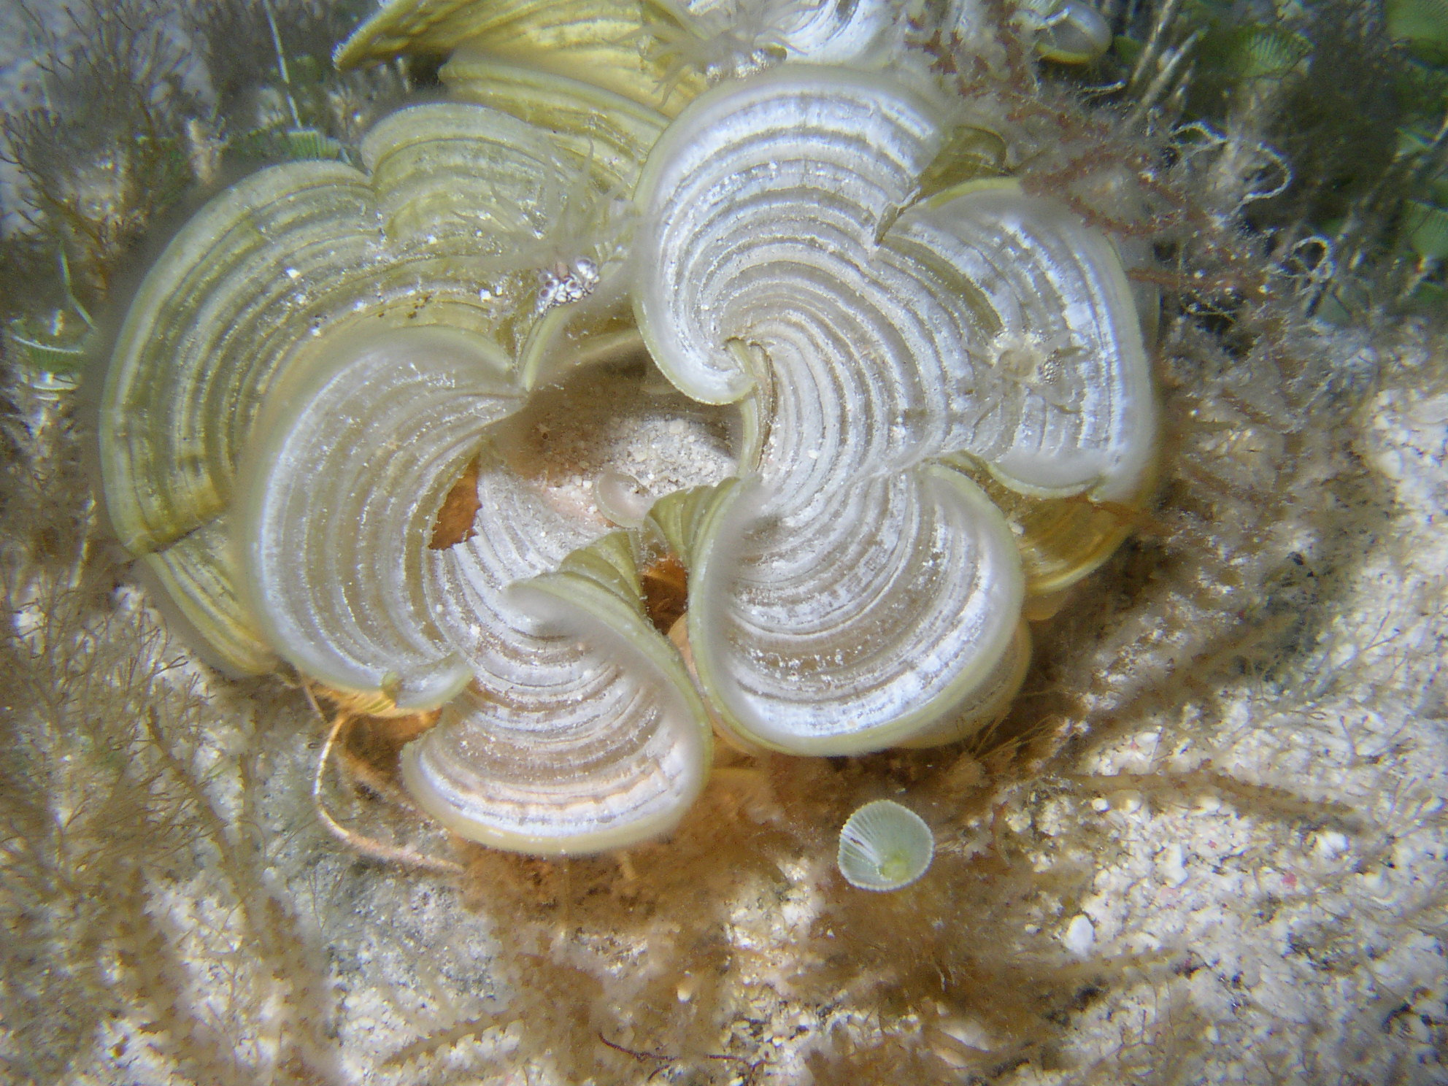

White Scroll Algae
Padina jamaicensis
Fun Facts:
- The white color
is from thin deposits of calcium carbonate on the upper blade surface.

Size:
2.5-6 inches

Depth:
5-35 feet

Visual Aid: Has Dense white to tan blades
with rounded margins.

